KIDDERMINSTER FOREIGN PARISH COUNCIL
CHAIRMAN:
Councillor B. Phillips
Tel: 01299 861419
CLERK TO THE COUNCIL:
Mrs E. Whitehouse
Tel: 01299 861026

You are summoned to attend the

ANNUAL MEETING OF THE PARISH COUNCIL
to be held at

TRIMPLEY VILLAGE HALL
on
MONDAY 16th June 2014
at 7.45p.m.
(Please note date, venue and time of meeting)
Members of the public and
the press are welcome to attend.
The meeting will commence with a
PUBLIC LOCAL FORUM with planned attendance by West Mercia Constabulary officer
The Agenda for the Parish Council meeting is attached.

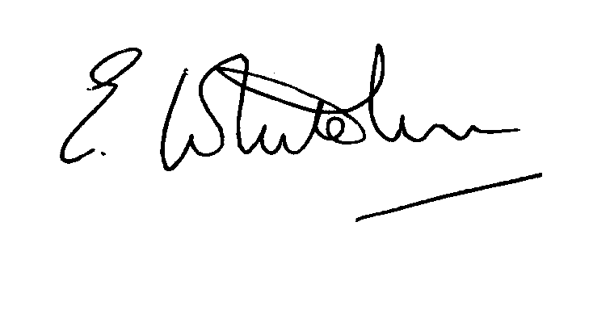

Dated: 8th May 2014 Clerk to the Council

e-mail: clerk.kiddfor.pc@googlemail.com

AGENDA
for the Annual Meeting of the Parish Council – 16th June 2014
(Note: The notation (I) indicates that the item is for information; (D) indicates that it requires a decision)
Public Open Forum for 15 mins – Police invited to attend

1. | Signing of Acceptance of Office by each Councillor |  | (D)
2. | Election of Chairman for 2014/15 & signing of Acceptance of Office as Chairman. |  | (D)
3. | Apologies for Absence and Approval of Reasons.
4. | Declarations of Interest.
5. | Election of Vice Chairman for 2014/15 |  | (D)
6. | Annual Report from Chairman for 2013/14 |  | (I)
7. | Annual Report from Rights of Way Warden |  | Enc.
8. | Confirmation of other Officers and Posts held for the Council, inc. Tree Wardens |  | (D)
9. | Acceptance and approval of General Power of Competence |  | (D)
10. | Approval of the Minutes of the Meeting(s) held on 19th May 2014 |  | Enclosure 1
11. | Planning and Development Control.
 | a. | Applications previously considered  To receive updated information on progress | (I)
 | b. | Applications received up to date of meeting inc:  14/0278 Extensions to improve existing rooms, provide additional facilities including new entrance, admin facilities and service provision (kitchen and laundry) at HIGH HABBERLEY HOUSE / HOLYFIELD HOUSE NURSING HOME, HABBERLEY ROAD, KIDDERMINSTER, DY115RJ. | (D)
 | c. | Compliance Issues | (I)
12. | Progress Reports.
 | a. | Highway Matters, to inc: | (I)
 |  | Flooding near to Mount Pool, due to blocked silt trap  Flood alleviation Works at Fountain, Low Habberley | (I & D)
 | b. | Flower and bulb planting | (I & D)
 | c. | Flooded footpath on Trimpley Green Common | (I)
 | d. | Marsh – weed eradication | (I)
 | e. | Newsletter | (I)
13. | Lengthsman – inc. tabling of any invoice received |  | (D)
14. | Financial Reports and Payment of Accounts
 | a. | Accounts for Payment  Any invoice tabled from lengthsman  PAYE for Clerk | (D)
15. | Worcestershire CALC Reports and Notices (if any) |  | (I)
16. | County and District Council Matters and other Correspondence  - District Council invitation re alternative delivery mechanisms – working with parishes  To include discussion on Boundary Commission proposed Boundary changes for District Wards. |  | (I)  (I & D)
 | a. | Any report from the County or District Councillor representatives not already tabled
17. | Road Accident Record
18. | Other matters which the Chairman, after consulting members, feels to be of an urgent nature.  (NOTE: Any items requiring a decision that do not appear on the agenda must either be dealt with by means of delegated powers or be deferred for consideration at the next meeting).
19. | Next Meeting: confirmation of date : 21st July to Include Annual Parish Assembly with speaker Stephen Ashton on Broadband speeds. |  | .(I)

