Councillors are Invited to  a MEETING of  CHADDESLEY CORBETT PARISH COUNCIL  To be held on  Monday 2 March 2009  At 7.30 p.m.  at Chaddesley Corbett Village Hall | 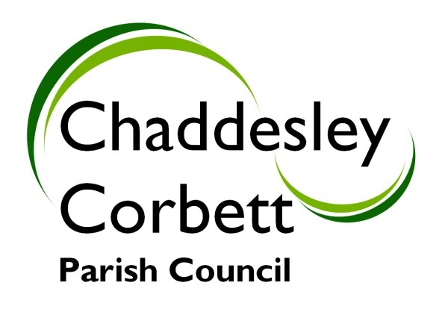
A G E N D A
7.25 ATTENDANCE BY POLICE.

7.30 1. APOLOGIES
2. Declarations of Interest
a. Declarations of Personal interest
b. Declarations of Prejudicial Interest

The meeting will now be adjourned for PUBLIC QUESTION TIME

Presentation by Rebecca Mayman of Wyre Forest District Council on District Council Local Development Framework, as presented at the LDF Exhibition held at Chaddesley Corbett Village Hall on Tuesday 10 February 2009.

7.40 The meeting re-opens
3. Minutes
a) Minutes of meeting held on 5 January 2009
b) Formal acceptance of Minutes of the Planning Committee meeting held on 5 January 2009

7.40 4. Progress Reports
4.1 Community Orchard – Cllr L Stockford
4.2 Neighbourhood Watch – Alerts
4.3 Emergency Plan
4.4 Feedback from January newsletter
4.5 Application for grant to cover additional bus service – Refused.

7.50 5 Consultation Documents/Meetings:
5.1 DEFRA – Improving Surface Water Drainage – Cllr R Pugh

5.2 Wychavon DC – Notification and Consultation on Draft Supplementary Planning Document on Water Management – Cllr R Pugh

5.3 Training on Breaches – Training session Monday 26 January 2009 at Wyre Forest District Council. – Cllr M Bird

5.4 West Midlands Regional Spatial Strategy Phase Two Revision – Tuesday 27 January 2009 Molineux Stadium. – Cllr M Bird

5.5 West Mercia Police Service 2009 and Beyond. Consultation Evening Tuesday 13 January 2009 – Cllrs Mrs J Fox and M Bird

5.6 Bromsgrove District Draft Core Strategy Consultation – Cllr M Bird response on behalf of the Parish Council.

5.7 Parish Forum – Tuesday 21 April 2009 – Items for the Agenda.

5.8 Worcestershire County Council Local Council Conference – Monday 27 April 2009, County Hall 7.00 p.m.

5.9 Surviving the Recession – Tuesday 3 March 9.30-1.00 p.m. – Wyre Forest Matters – Surviving the Recession. Cllr J Swift booked to attend.

Items for Decision/Discussion

8.15 6. Review of Web-Site.

7. Consultation on Publicity-Code of Practice – Cllr J Swift

8. Computer Courses

9. Harvington Hall Lane – Recommendations from Working Group – Cllr D Thomas

10. Formal acceptance of the accounts for the quarter up to December 2008.

11. Annual Parish Meeting – Wednesday 20 May 2009 – Proposed Agenda

8.45 12. Chairmans Report

8.50 13. Reports from Councillors Representing Outside Bodies
13.1 Charity Trusts – Cllr S Williams
13.2 Wyre Forest Community Housing – Cllr G Vernon
13.3 School Update

8.55 14. Allotments - Report from Cllr L Stockford

9.00 15. Burial Ground - Report from Cllr K Bartlett

9.05 16. Lengthsman Scheme and Highways- Cllr G Vernon

9.10 17. Financial Report
17.1 Receipts and Payments

9.15 18. New Highways Issues and Items for next meeting.

Dates for your diary: Next Meeting 6 April 2009.

Signed………………………………………………. Clerk

