Councillors are summoned to  a MEETING of  CHADDESLEY CORBETT PARISH COUNCIL  To be held on  Monday 4 July 2011  At 7.25 p.m.  at Chaddesley Corbett Village Hall | 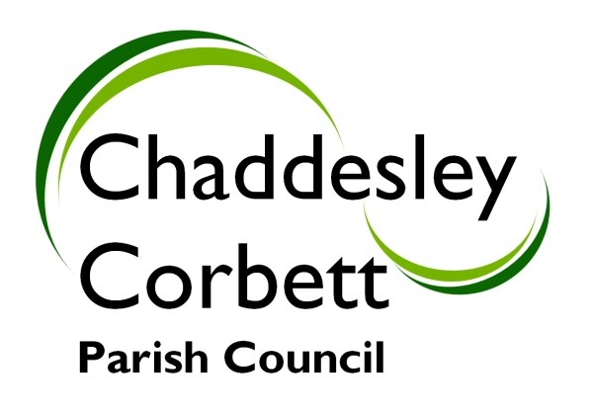
A G E N D A
7.25 POLICE.

7.30 1. APOLOGIES
2. Declarations of Interest
a. Declarations of Personal interest
b. Declarations of Prejudicial Interest

The meeting will now be adjourned for PUBLIC QUESTION TIME

7.35 The meeting re-opens

3. Minutes
a) Minutes of meeting held on 6 June 2011
b) Formal acceptance of Minutes of the Planning Committee meeting held on 6 June 2011

7.40 4 Councillors Reports
4.1 Chairman’s Report
4.2 District Councillor’s Report
4.3 County Councillor’s Report

7.50 5. Chaddesley Corbett Parish Matters for Discussion/Decision
5.1 Feedback from Annual Report and Survey Form.

5.2 To consider practical support for the hearing application against the Hartlebury Incinerator.

5.3 Proposed changes to speed limits on A448 - to receive a report on a meeting held on 16 June 2011.

5.4 Community Right to Build – To consider the possible redevelopment of the Old School site for the benefit of the community.

5.5 To review meeting of Wyre Forest Area CALC held on Tuesday 21 June 2011.

5.6 Lengthsman Scheme and Highways – To receive a report on work undertaken during the last month - Cllr G Vernon.

5.7 Allotments and Community Orchard – To receive a report from Cllr L Stockford .

5.8 To Review ‘The Power of Well-Being Community Engagement Statement of Intent’ and pass a Resolution to Re-Adopt the Power of Well Being.

5.9 To consider a NALC request for information – “Should the forthcoming Neighbourhood Plans have greater weight than the local plans of the principal authorities?” Should the Parish Council consider preparing a Neighbourhood Plan?

5.10 To consider a proposal to Wyre Forest District Council for Chaddesley Corbett to host an “Armed Forces Flag Waving Day”.

8.30 6. Dates for Meetings:

8.35 7. To Receive Reports from Cllrs Representing Outside Bodies
7.1 Community Housing Group – Cllr G Vernon
7.2 Education Foundation Trust – Cllr B Green

8.40 8 Consultation Documents
8.1 Wyre Forest District Council – Consultation on Local Development Framework – Cllrs L Stockford, D Thomas
8.2 Consultation of the proposed Worcestershire Agreement – Completed by Clerk and Chairman
8.3 The Worcestershire Landscape Character Assessment (LCA)

8.50 9. Clerk’s Report on items of correspondence for Information Only
To receive a written report from the Clerk on items of information – no action required.

8.55 10. Financial Report
10.1 To approve Receipts and Payments as per schedule
10.2 To approve quarterly Bank Reconciliation to end June 2011.

9.00 11. New Issues and Items for next meeting. Date of next Meeting Monday 8 August 2011.

Signed………………………………………………. Clerk

