HONEYBOURNE PARISH COUNCIL
Worcestershire
To all Members of the Council

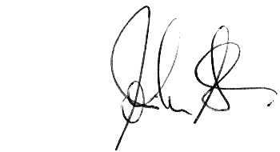
You are hereby summoned to attend an extraordinary meeting of the Parish Council to be held at the Village Hall on Monday 21st October at 7.30 pm for transacting the following business only.
John Stedman: Clerk to the Council 31 July 2026

Prior to the meeting Mr Sean Smythe will present Lioncourt’s proposals on the adoption of the Lioncourt site public open space and other infrastructure items as indicated in his email.
Q&A time will follow the presentation

Meeting Agenda

- Apologies:
To receive apologies and agree the reason for absence : Cllr Brian Johnson, David George &
Cllr Alistair Adams
- Disclosures of Interests:
Register of Interests: Members are reminded of the need to update their register of interests.
  - To declare any Disclosable Pecuniary Interests in items on the agenda and their nature.
  - To declare any Other Disclosable Interests in items on the agenda and their nature.
Councillors who have declared a Disclosable Pecuniary Interest, or Another Disclosable Interest which falls within the terms of paragraph 12(4) (b) of the Code of Conduct, must leave the room for the relevant items. Failure to register or declare a Disclosable Pecuniary Interest may result in the commission of a criminal offence.

- To consider any matters arising from the Lioncourt proposals.
- To consider the Clerk’s report on Salt Grit bin filling by WCC
- Meeting Dates
  - To confirm the next Ordinary Meeting is scheduled for the 12th November at the Village Hall at 7.30

End.

