Annual Parish Meeting.

This Year the council had a few more attendees to the annual parish meeting.
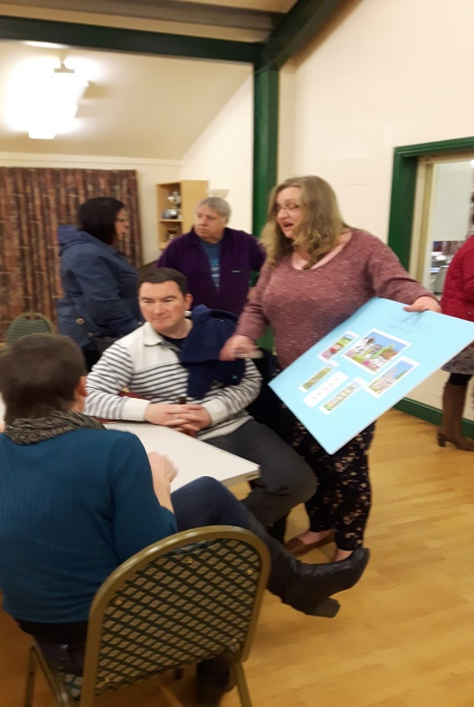

Bus Shelter.
Judith Selkirk came and showed the council and members of the public the finale designs for the bus shelter. This was met with a lot of enthusiasm. Toby the overall winner was very pleased with the Artists design.
There was a lot of enthusiasm in the idea that the parish would help to paint the bus shelter.
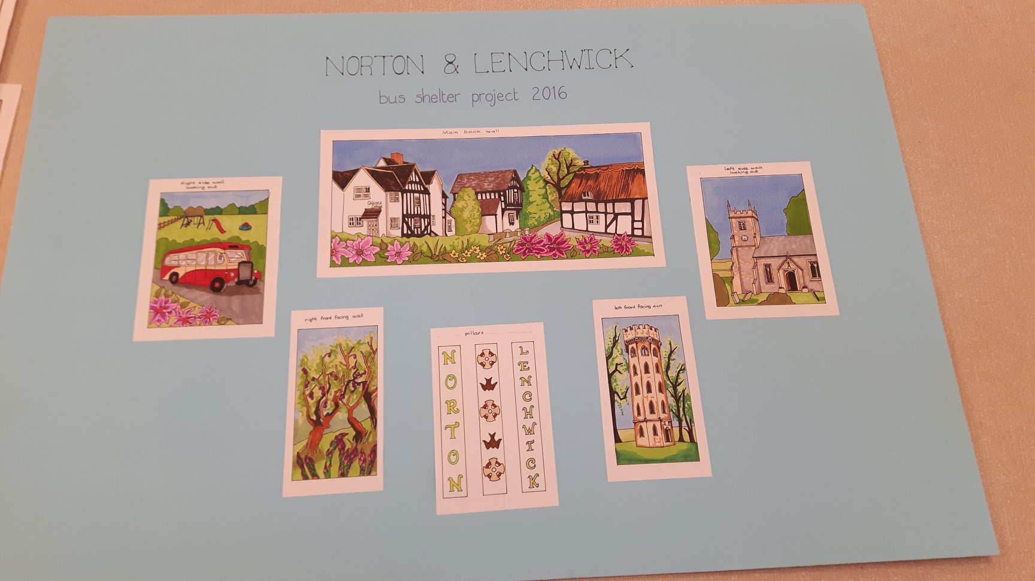

Suggestions for the new homes bonus money.
At the meeting we had a list of ideas and suggestions for the spending of NHB.
These were:-
New notice boards.
Money for the materials for the bus shelter.
Wet pour for the Goal post in the park.
New park signs
A new play piece for the park.
Speeding ideas.

The clerk got the children who had attended the meeting to choose a play piece from a selection she had got from realise futures.
1st winner was the Pirate boat.
2nd was the Race car.
3rd Long Boat.
The clerk informed the children that it would depend on how much money the council had left as to which piece they got.

All suggestions were again met with enthusiasm, the only issues was that one parent suggested the tractor would be more usable for the play park equipment.

The public that attended enjoyed the relaxed atmosphere, and the cheese and biscuits.

