


Chaddesley Corbett Parish Council

Annual Report
2006/7

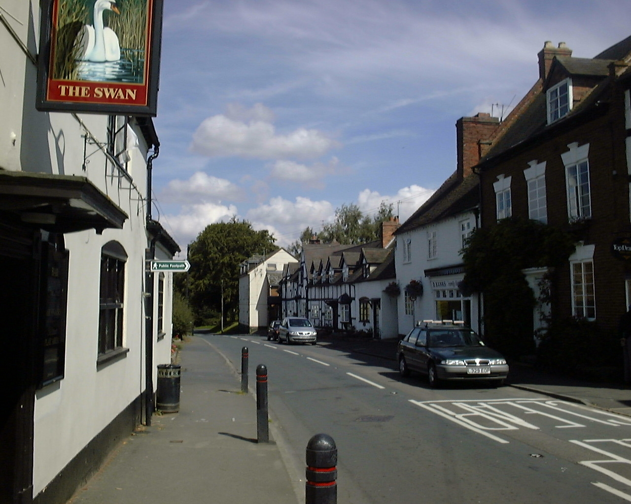

The Parish of Chaddesley Corbett includes:

The Village, Bellington, Bluntington, Brockencote
Cakebole, Hillpool, Drayton, Harvington, Lower Chaddesley
Mustow Green (East), Tanwood, Winterfold, Woodrow

The Chairman’s Annual Report
The year under review began with a thorough appraisal of the training needs for councillors to get to grips with their responsibilities in law and to the parish and ended with the Award of the Quality Status Certificate – the first in Wyre Forest. No mean achievement and much credit to our Clerk Yvonne Scriven. The Award recognises our commitment to training and qualifications, the Newsletter and website, the open-to-all style of our Council meetings, and the Annual Parish Meeting, the publication of minutes and agendas which conform to exacting standards. The importance of our communication effort cannot be emphasised too strongly, it is a constant challenge to all of us.

The amenity value of the Parish footpaths, the grass cutting, the allotments, the burial ground, the work of our lengthsman continue to represent the quality we all seek in keeping the Parish so attractive, tidy and safe.

Looking forward there is much valuable liaison and advisory benefit to the Parish in the work of the Steering Committee, the Planning Committee, our participation in the consultative rounds for example with the West Midlands Regional Spatial Strategy, the Transport Strategy, the Partners and Community Together scheme which is helping to make our Parish safer, the Worcestershire County Association of Local Councils which is an impressive organisation and is playing a vital part in our revitalisation. Ahead lies a package of reforms to further devolve the authority and responsibility and establish a partnership between central and local government in all tiers, to create more room for local discretion and to engage more effectively with local people and local issues.

On the financial front we consider every item of expenditure in detail and in full public view. Cuts in expenditure have been achieved, however the principle of balancing income and expenditure rather than drawing on reserves is helping to sustain the effective delivery for residents of an increased and improving range of services and benefits.

There are many concerns outstanding: parking, the school, a housing survey to name but three which will continue to raise the interest and excitement level as the controversy abounds.

Finally my thanks to Liz Mack who resigned this year and to Dave Thomas who has joined the Council, to the many who have attended our meetings as observers, lent support, given advice, your continued participation is very helpful, indeed important, and I extend a welcome to your continued interest and assistance.
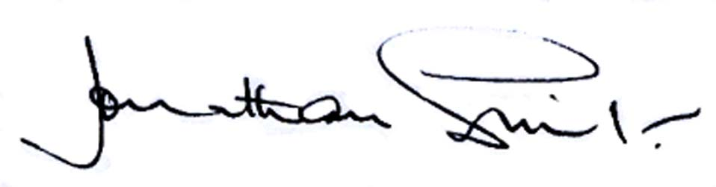

Annual Parish Meeting
The Annual Parish Meeting was held on Wednesday 23 May 2007 and was attended by most of the Parish Councillors and 25 residents. A range of speakers addressed the meeting and residents had an opportunity to raise matters of concern. A full report on matters raised at the meeting is included in this Report. Efforts will be made to try to increase awareness of the activities of your Parish Council and to encourage participation.

Parish Plan Update
Following recommendations made in the Parish Plan, a Workshop was set up last June and much has been accomplished. The majority of the proposals have been adopted by the Parish Council. In some areas progress would appear to be slow, but it was felt essential to wait until the site for the new school had been determined before making decisions which would affect our future for many years to come. A Village Design Statement is being prepared as we, your elected Parish Council, are of the firm belief that the location of the school and the Design Statement are fundamental to any future development in the area.

Communication
In this area, we are committed to better communications with residents; we have a very informative website, where you can find out about all current planning applications, with a direct link to the District Council web site. For those without internet facilities we have been trying to arrange for free distribution of St Cassian’s Parish Magazine to all residents, which includes copies of Parish Council Minutes, notices and other items of interest. If this cannot be achieved, then the Parish Council will circulate its own quarterly Parish Newsletter which will be sent to every household on the electoral role. We are increasing the number of notice boards in all areas where you can view Minutes, Agenda, notices and other items of interest to you all.

Housing Needs Survey
We will shortly commission a new Housing Needs Survey, the results of which should be published in the New Year. A copy of the questionnaire will be sent to every household in the Parish and we ask your co-operation in completing and returning it, as it is your opportunity to influence planning activities in your area.

Life Long Learning
They say you are never too old to learn, and this has been demonstrated by the large number of residents who have attended computer training courses, either at the school, or on the Computacoach. If you would like to attend a course please contact the clerk for further details. Plans for the new school include providing facilities for adult learning and recreation.

Project Carbon
This new incentive seeks to raise awareness of the effects of climate change and take positive initiatives to reduce our carbon footprint. Due to climate change and human activities last October was the warmest for 150 years and over the past year the temperatures for four months have broken all records. 200 years of burning oil could be responsible for this change. One initiative is to use low energy light bulbs. You may not have tried these yet and the Parish Council is considering ways to raise awareness of the considerable amount of money you could save if you just simply change your light bulbs.

We are trying to arrange for a selection of low energy light bulbs to be displayed locally and ordered through Marches Charity who can offer a wide range of sizes and shapes, many of which are not readily available in the shops. More information on this initiative will be available shortly – watch the Notice Boards.

Preservation of our planet and our environment is important to us all and your Parish Council are currently exploring other ways to improve our environment.

Village Notice Board
A comprehensive range of facilities and activities in the Parish is available to everyone and in order to improve communications a new Public Notice-Board will shortly be erected in Chaddesley Corbett village. Everyone can use this to advertise events, plays, organisations, functions, fund raising, etc. Anyone wishing to place a notice on the board should contact the Clerk in the first instance. If successful further notice-boards can be placed elsewhere around the village.

Worcestershire County Council
and Wyre Forest District Council – One Stop Shop
The newly opened Hub in Kidderminster can deal with your local authority problems and provide local information. Call in or visit their web site on www.worcestershire.gov.uk

Lengthsman Scheme
This joint initiative between the Parish Council and Worcestershire County Council has been very successful. With the appointment of Bill Waldron from Drayton, the last twelve months have seen a programme of widening and weeding footpaths, cutting back overhanging hedges, cutting back vegetation from around signs and keeping them clean, replacing bollards, widening the carriageway and digging grips, and litter collection. In the winter, work was completed to prevent flooding along Drayton Road and Woodrow Lane. Some flooding still occurred but this was quickly dealt with. The work was completed within budget. Our thanks to Cllr Mr Phillip Tetstall and Bill Waldron for all their hard work, which is much appreciated.

PACT – Partners and Community Together
Meetings are held at regular intervals at Kidderminster Library, attended by the Chief Inspector and representatives from various wards and organisations within Wyre Forest. The aim is to discuss local community safety issues and be advised of the actions the police had taken to address these issues. Crime Stoppers offers a confidential service to enable the public to pass information to the police that would assist them in investigations of any criminal or anti-social activities. Trained personnel deal with your call, no names are exchanged and your phone number is untraceable. Rewards are sometimes available for information which leads to conviction. Phone number for Crime Stoppers is 0800 555 111.

A local police base has opened on Queen Elizabeth Road on the Comberton estate and Sergeant Lane and local officers PC Hill and Hemmingway, together with CSO Goode, can be contacted there. Although not operational 24 hours a day the officers can be contacted on 01562 747384 for non emergency issues. A message service is available.

A report had been received from CSO Goode that a vehicle would soon be made available so she would be able to patrol the area more frequently in the future. It was noted that sheds had been broken into on the allotment site recently. Residents need to be more vigilant and report incidents immediately. The Police have offered to come to the Allotment Site and carry out a ‘property marking’ exercise for tenants.

Your contact for Neighbourhood Watch is Michael Bird.

Allotments
This year the decision was taken to open these to non-residents of the Parish, which has resulted in all the existing plots being let, and we now have a waiting list. We are now considering providing a water supply. Tenants will shortly form a Tenants Association and will join a National Association, run competitions and generally become more involved in the Community.

Land at the rear of The Hemmingway
For the last year we have been looking into uses for the Land behind Hemming Way. We have had a number of suggestions for uses from a park to a community vineyard, dog exercise area and more allotments. So we took the decision to form a working group to progress the options. The committee is made up of four Parish councillors and representatives from the parish. We had a meeting at the end of last year and it was decided that we would look in to creating a community breathing space. This was suggested after members of the committee were inspired by the BBC’s documentary Breathing Places for the Community. The space would include trees, paths, seating areas, meadow grasses and an area for children - a place where we could all enjoy the beautiful area in which we live. We are still awaiting one of the outline plans for the space then it will be presented to the parish council for their input. Once an outline plan has been passed we will approach the land agents to see if we could make amendments to the lease of the land, currently it is renewed once a year. For us to be eligible for grants we would need to extend this.

Chaddesley Corbett First School – Update
In January 2005 it was agreed that Wyre Forest would switch to a two tier instead of 3 tier school, with Chaddesley Corbett First School increasing in size to take in two more years. In May 2005, David Mills was appointed Project Leader and now, 2 years down the line, the planning application has been validated; this had taken 4 months, and the public had until 7 June to send in letters of support. The vast majority of residents support this application.

As this is a development in the Green Belt, the impact on the landscape is paramount. From an artists’ impression some of the buildings are buried in the ground to reduce impact and heat losses and are designed to look like an agricultural building. The proposed road junction is acceptable to Highways, including Public Access areas, badminton court, sports, swimming pool, if funded, which could be made available for community use. The development would include IT, a library and facilities for training. The remaining land would be left for agricultural use at the moment. A footpath access (permissive path) would cross land retained by Rowberry’s Nurseries. Car parking, with coach spots and hard standing were included and are considered adequate. However, there are still some issues to resolve in relation to health and safety, access, drainage etc.

The school would accommodate a maximum of 210 pupils for the catchment area of Chaddesley Corbett and Stone. If Outline planning is approved it should be possible to complete the project by September 2009.

The District Council have to date indicated they would not support this development in the Green Belt, but it was hoped that public support will persuade them to change their mind.

Burial Ground
We still have a few new plots available, and of course second burials will continue for many years. In order to reduce maintenance costs a weekly collection of waste has been arranged through the District Council. Residents will be asked to segregate their rubbish into green, glass and paper.

New plots are available in St Cassian’s Churchyard and requests should be made to Rev. John Cox. It is not possible to pre-buy or reserve plots.

Parish Footpaths
The annual end of the year report had been completed in early April and recorded the actual work completed against the proposed; the only changes were path re-generation and step refurbishments and 2 gate upgrades. The Proposed work schedule for the year 2007-8 has been submitted, after reviewing the previous 4-5 years work it was decided to concentrate on access to path points from the highway, particularly where a gradient is involved. Steps, and in some cases handrails, were proposed as refurbishment and new installation. Also included is path surface re-generation, signposts, way-mark posts, strimming and general under growth clearance, plus the ever present ‘emergencies’.

Sandi Holding, our excellent Parish Footpaths Warden, which is a voluntary position, emphasises the need to walk the paths, keep dogs under control and report any situations. In our Parish there are more than 80 paths, covering approximately 50 miles, there is no ‘Right to Roam’, no Common Land, no mountains, moor, heath or down. You are encouraged to keep to the paths and enjoy our lovely Parish.

The Parish Council are most grateful to Sandi for her dedication and enthusiasm.

Sports Club Facilities
Rob Bond, Chairman of Chaddesley Corbett Sports Club, explained that the Sports Club was founded in 1977, but the cricket club was founded in 1862 and moved to the present ground in 1937. The facility is now open 12 months year, and provides facilities for the cricket, football and rugby clubs. A Committee runs the Sports Club for anyone who wants to play and has no catchment area. Several youth clubs use the facilities on a Saturday. The Committee would like to develop the facilities into a community sports club for people in this area and would be more than happy to co-operate with the school. The Club house has a bar with good beers and would like to improve these facilities. The running costs are approximately £10,000 per year, and income amounts to £6,000, leaving a shortfall. At best it is a break-even situation.

Other sports : Cllr Philip Tetstall outlined other recreational facilities available in the area such as fishing, cycling, field target with air guns, and a model aircraft flying club. Contact details are contained in the list of contacts at the end of this report.

Urban Grass Cutting
We are again undertaking our own urban grass cutting and in response to our Parish Plan, intend to extend this service to cover rural grass cutting in the future. Currently we provide and finance some verge cutting when the vegetation becomes badly overgrown.

Annual Precept 2007
Expenditure for the current year exceeded income by £5,325 and the Financial Committee of the Parish Council formulated a budget for the current year which indicated that in order to cover expenditure this year it would be necessary to increase the Precept this year. This has resulted in an increase on the rates for each household which on average means 58p per household per week. Nobody likes increased rates, but we need to retain our reserves which have dwindled in recent years as a result of providing support to many worthwhile organisations within the Parish. We need money available to assist these and others in the coming year, and to finance many new initiatives we are considering. We will continue to monitor expenditure carefully and ensure residents get value for money.

Financial Report
Annual Audit
This will take place on 23 July 2007 and records may be inspected from 22 June to 22 July 2007. An internal Working Group has been set up to check our accounts prior to submission to the external auditors. Last year we spent some of our reserves providing local services and supporting worthwhile projects, so this year it has been necessary to increase the Parish Precept quite considerably. This increased Precept will simply cover anticipated expenditure for the financial year April 2007 to March 2008, maintaining a modest reserve to meet unforeseen expenditure and build for the future. We are sure you can see that this represents good value for money and that this money is spent for the benefit of your local community.

A summary of the accounts for the year ended March 2007 is given below:

Receipts
B/F from 2005/6 £29,865

Annual Precept £11,040
Section 136 Funding £ 1,656
Burial Ground £ 1,717
Parish Footpaths £ 1,495
Lengthsman Scheme £ 2,150
Urban Grass Cutting £ 1,084
Allotment Fees £ 438
Other Receipts £ 437
Interest £ 678
VAT Recovered £ 1,243
Transfers from Deposit Account £ 8,500
TOTAL £30,438

Expenditure
Clerk’s salary £ 4,441
Administration/Other £ 8,196
Lengthsman Scheme £ 2,869
Allotments £ 711
Burial Ground £ 1,483
Parish Paths £ 2,414
Transfers to Deposit Account £ 2,000
Donations £ 7,150
TOTAL £29,264

At the end of the year the Parish Council had reserves of £24,540. The Burial Ground managed to cover costs this year, and although the allotments made a small loss, they are now fully let and this situation should improve in the future.

Planning
Planning Committee meetings are held immediately after the monthly meeting of the full Council. The Committee has dealt with a typical range of applications, ranging from simple extensions to quite large developments. A recent innovation is that, in common with other local Planning Committees, we have been provided with a lap top computer, a projector and screen so that the plans for a particular application can be viewed large-scale instead of members having to crowd around a pile of paper plans inconveniently laid out on tables. There have been some teething problems but eventually the system will be of benefit since members will be able to give applications much more detailed scrutiny than has been possible in the past.

It is not generally known that not all extensions need formal planning permission. Examples include porches, conservatories and detached garages. For example you do not need planning permission if the garage is:

- NOT built between your house and the highway unless the highway is more that 20 metres from the garage
- NOT built over half of the land on your property
- NOT more than 4 metres high within 2 metres of your boundary
- NOT built within 5 metres of extensions that have used up your permitted allowances

If the floor area is between 15 and 30 sq metres it MAY be however be necessary (depending upon certain conditions) to satisfy building regulations. On the other hand, if the floor area is less than 15 sq metres it will NOT have to satisfy the regulations, whereas if it is more than 30 sq metres it WILL have to.

Similar considerations apply to conservatories etc.

Details of precisely what is and is not allowed are to be found on the Wyre Forest DC web site. The exact address is www.wyreforestdc.gov.uk/corpgen/new/planfaq.

District Councillors
As well as being a member of the Parish Council, Cllr Steve Williams is also one of our District Councillors, and is Chairman of the Planning Development Control Committee, and the Planning Enforcement Committee. Locally he has chaired 4 meetings of the Margaret Delabere Alms House Trust and 7 meetings of the Chaddesley Corbett Education Foundation. He was also MC for the village fete and caller for a bingo night at the village hall! As well as his other duties for the District Council, he has given major speeches to the full Council on a single site, shared services and closure of rural Post Offices.

Pauline Hayward is our second District Councillor and often attends Parish Council meetings.


JONATHAN SWIFT

Responsibilities – Chairman.
Telephone: 01562 777268.
jonathanswift10@btinternet.com.

Parish Councillor, and now retired International businessman I have gained some experience of the consultative process and decision making. I am glad to be available to put this experience to work for the benefit of the community. I am a resident of 20+ years in this Parish and I feel a commitment to help support and maintain the neighbourhood I enjoy so much and to encourage others to do the same.

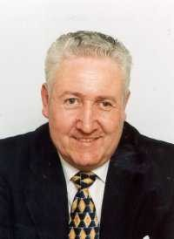

STEVE WILLIAMS

Responsibilities – District and Parish Councillor,
Charitable Trusts
Telephone: 01562 777536
Email: chaddesleycouncillor@yahoo.co.uk

I have lived in Chaddesley Corbett for over 60 years, my Grandfather and Uncle were members of the Parish Council for many years.

I am Chairman of the Margaret Delabere Almshouse Trust and the Parish Council’s representative on the Parish Forum.


KEN BARTLETT

Responsibilities – Vice Chairman, Burial Ground
and sits on
Quality Status Committee.
Tel 01562 777 453
Email kenbartlett@lineone.net

I am a chartered accountant and have lived in Chaddesley Corbett for over 30 years.

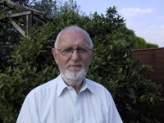
MICHAEL BIRD – CHAIRMAN-PLANNNG

Responsibilities – Planning Applications
Telephone:01562 777728
E-mail michaecjlbird@tiscali.co.uk

I was a lecturer for 31 years and came to live in Woodrow in 1987. I have taken an interest in Village affairs and have enjoyed my involvement with Neighbourhood Watch. I am very interested in all aspects of planning.

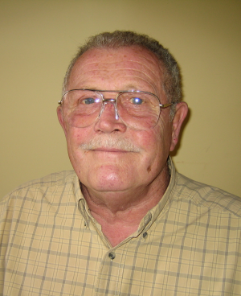
GEOFF VERNON

Responsibilities – Member of The Oaks
Community Hall Management Committee and
Wyre Forest Community Housing,
Tenants Consultative Committee
Telephone: 01562 777365

I am pleased to have been working for the last year with a new team of Parish Councillors. Team spirit is much in evidence and it is effecting changes for the benefit of all Parishioners. Much has been done and changes made for the better and the future holds even more promise for our community.


JANET FOX

Responsibilities – Member of Police
Consultative Committee, PACT and Education
Chairman of Parish Plan Working Group
Telephone 01562 777559.
e-mail: janfox@virgin.net

As a representative for PACT, I am wiling to convey any policing type problems to the meeting eg speeding cars, inappropriate behaviour, etc. In addition as the Chair of the Parish Plan, I will endeavour to encourage the Parish Council to action the proposals that have been adopted by them so that those aims and objectives do come to fruition!!


LEO STOCKFORD

Responsibilities – Allotments,
Vice Chairman, Planning Committee
Telephone: 01562 777746.
e-mail: leo.stockford@hp.com

Over the last year I have worked hard to let out the allotments and make them a viable and vibrant area. By reducing the size of the plots and making them more manageable I have doubled the number of people letting them. I am currently looking into providing a water supply. Over the next year I hope to develop the plans for the community area on the land behind Hemming Way and to continue to work with the tenants.

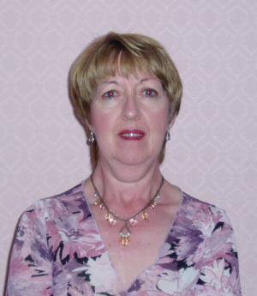
PHYLLIS PARDOE

Responsibilities – Trustee and Member of the
Village Hall Committee,
Trustee Education Foundation Management
Committee and Margaret Delabare Charity
Telephone: 01562 777969

I am a Trustee of the Village Hall, helping to keep the Hall running to its high standard and also helping with the new school build.


PHILLIP TETSTALL

Responsibilities – Lengthsman Scheme,
representative on Wyre Forest Area CALC

Telephone: 01562 777569.
e-mail: Phillip.tetstall@tesco.com

I have a particular concern for the state of the highways and environment and therefore using the Lengthsman scheme to its full potential.

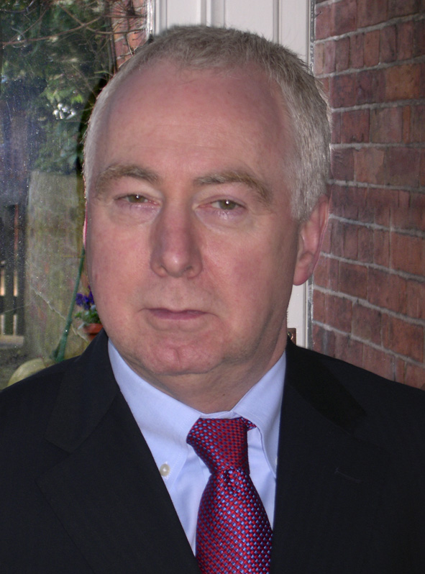
DAVID THOMAS
Responsibilities – Transport

Telephone: 01562 777315
e-mail: dave.thomas@uk.ibm.com

I have lived in Woodrow for over 10 years and am committed to helping preserve the rural character of Chaddesley Corbett. My concern is to balance progress with protection of the unique heritage of this beautiful village and surrounding countryside. I hope that my experience as a Business Consultant, working with Government bodies and major international companies, can be used to the benefit of our community and local decision making.



MARTIN WALFORD

Responsibilities – Representative on
Wyre Forest Area CALC

Telephone: 01562 777325.

I am an Engineer and have livid in Hemming Way for over 25 years. I am concerned with preserving our wonderful village for the benefit of all parishioners.

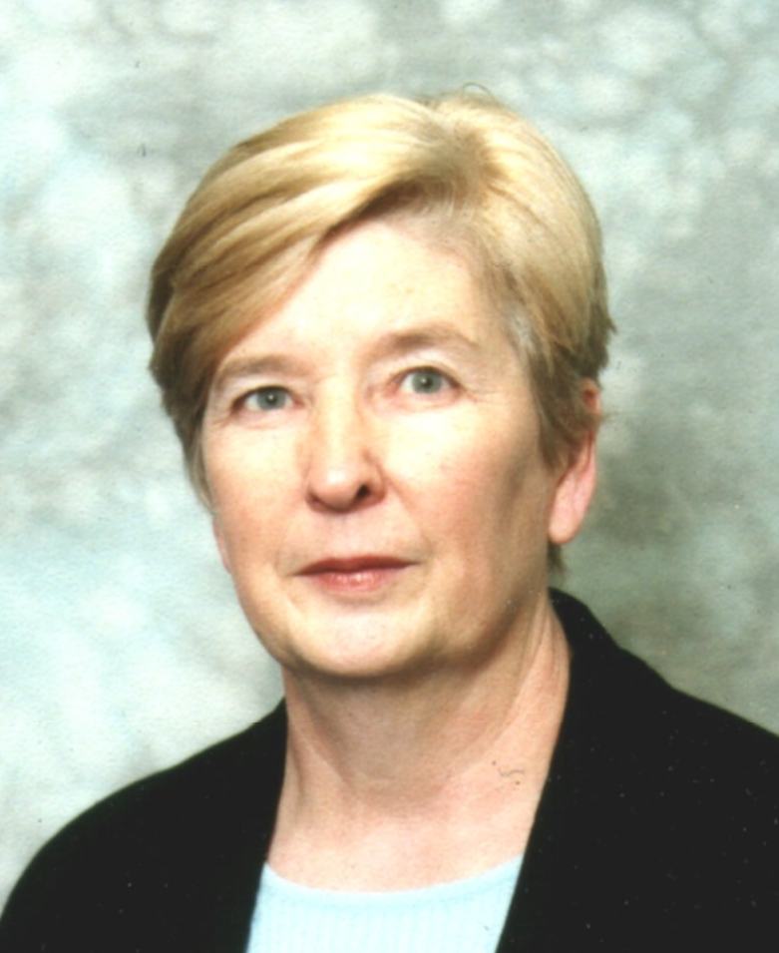
YVONNE SCRIVEN

Clerk to the Parish Council
Telephone: 01299 851654
Mobile: 07793 621594
Fax:01299 851444
e-mail: Yvonne.Scriven@btinternet.com.

I have been Parish Clerk for 6 years, and was previously Clerk for Elmbridge for 5 years. It was necessary to gain an AQA Certificate in Local Administration before the Parish Council could obtain Quality Status. Having satisfied all the criteria, I am pleased to have been able to play my part in gaining this prestigious award, which should make it possible for the Parish Council to have a much greater say in their own affairs in the future.
Bell Ringers  Harry Grove  777967 |  | Brownies  Brenda Bartlett  777453 | Butcher  Mark Page  777244 |  |  | C.A.T.S.  (Secretary) Jackie Brown  777537 | Chaddesley Corbett Primary (Head Teacher) Fran Jones  777312
Chaddesley Corbett Educational Foundation  (Clerk) Margaret Green  777367 |  | Chaddesley Farmers Club  Bill Meredith  777342 | Chaddesley Corbett Pre- School Nursery  (Supervisor) Rose George  777573 |  |  | Chaddesley Corbett Pre- School Nursery  777356 | Chaddesley Woods Wardens  Mervyn Needham 777461  Bernard Cook 777308
Chaddesley Corbett Village Hall (Bookings)  Jayne Russell  (07791) 508283 |  | Chaddesley Corbett Village Hall Payphone  777051 | Conservative Association  (Chairman) Val Adams  777113 |  |  | Cricket Club  (Chairman) Bob Bond  (01527) 575006 | County Councillor  Stephen Clee  (01299) 402338
District Councillor  Stephen Williams  777536 |  | DOCTORS  Dr Spalding & Dr. Wilkie  777239 | Flower Rota for St. Cassian  Rosabelle Needham  777461 |  |  | Football Club  Dave Yardley  632956 | Footpath Officer  Sandie Holding  777575
Fox Inn  James and Michelle Wood  777247 |  | Friends of St. Cassian  (Chairman) Michael Shaw  777401 | F.V.A.  (Chairman) David Hislop  777493 |  |  | Gardening Club  (Secretary) Audrey Cook  777308 | Harvington Hall Office  777846
History Society  (Chairman) Robin Blakeway  777679 |  | Hockey Club  (Chairman) John Fallows  (01299) 403613 | Hockey Club – Junior Section  (Secretary) William Mack  777343 |  |  | Methodist Chapel, Bluntington  John Rhead  (01527) 870488 | Mothers & Toddlers  Jill Beard  829301
Neighbourhood Watch  Michael Bird  777728 |  | Oaks Community Hall, Harvington  (Bookings) Shelagh Gardener  777496 | Parochial Church Council  (Secretary) Margaret Green  777367 |  |  | CRIME STOPPERS  0800 555 111 | POLICE KIDDERMINSTER  (08457) 444888  Non-Emergencies
Post Office, Shop & Tea Rooms - Chaddesley  Richard Vale  777257 |  | Post Office & Dairy Stores - Harvington  Michael & Virginia Gibbs  777233 | Riding for the Disabled  Helen Kershaw  01527 872998 |  |  | Royal British Legion  Maurice Walker  777352 | Rugby Football Club  Mark Page  777700
Rugby Club - Junior Section  Debbie Newbold  777404 | Sports Club Pavilion  777691 |  |  | St. Cassian’s Church  Rev. John A. Cox.  69438 | St. Cassian's Churchwardens  742358  01527 870342 |  |  | St. Mary's RC Church, Harvington  Fr. David  777319
Swan Inn  Jean Rawson  777302 | Talbot Inn  Rupert & Hilary Boden  777388 |  |  | Wednesday Club  (Secretary) Margaret Green  777367 | WI - Brockencote  (President) Chris Jordan  777506 |  |  | WI - Chaddesley  Susan Condy  66188
Field Target (Air Guns)  Tony Cook – 01384 827401  Phillip Tetstall - 777569 |  |  |  | Model Aircraft Flying Club  Stuart Hancox – 01384 567577
Fishing Venues  Willow Marsh – 777406  Winterfold Park Pools – 777963  Sion Farm - 730386 |  |  |  | Cycling (Road)  Malcolm Inchley – 770025  Phillip Tetstall - 777569 |  |  |  | Cycling (off road)  Nigel Perrins  07973 307003

Contact details for the Clerk:

Yvonne Scriven
Urloxhey House, Elmbridge,
Worcs WR9 ONQ.
Telephone: 01299 851654
Mobile: 07793 621594
Fax:01299 851444
e-mail: Yvonne.Scriven@btinternet.com.

Parish Council Web-Site: www.chaddesleyparishcouncil.org.uk

