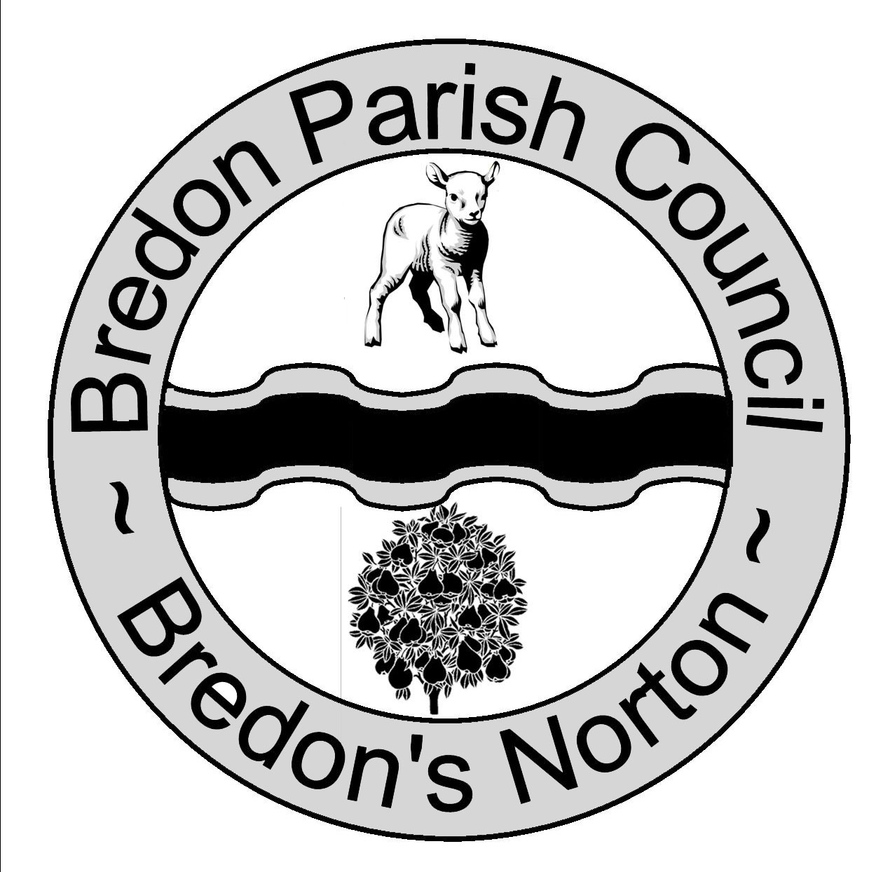 Clerk Ms J Shields Chairman Mr K Brown
Potenza
Chapel Lane
Kinsham
Nr Tewkesbury
Glos
GL20 8HS

Bredonpc@btinternet.com
www.bredonparishcouncil.org.uk

A meeting of Bredon Parish Council will be held at Bredon Village Hall on Monday 7th December 2009 at 7.15pm.

From 7.15pm residents are invited to give their views and to question the Parish Council on issues on the Agenda; additionally they can, at the discretion of the Chairman, raise issues for future consideration. There will be a time limited of 5 minutes per item and 15 minutes in total. Members of the public may not take part in the Parish Council meeting itself.
Mr Malcolm Dunn will answer questions regarding the Bredon Community Play and Recreation Group (BCPG) plan for the playing field.

AGENDA
- Apologies for Absence.

Declaration of Interests.
- Register of Interests.
Councillors are reminded of the need to update their register of interest.
- To Declare Any Personal Interest In Items On The Agenda And Their Nature.
- To Declare Any Prejudicial Interest In Items On The Agenda And Their Nature.
(Councillors with prejudicial interests must leave the room during the relevant items)
    - To Consider The Adoption Of The Minutes Of The Meeting Held On The 9th November 2009.
    - Correspondence For Information
    - Invoices to Be Paid.
    - Progress Reports for Information.
- Clerk.
- Playing Field Support Group.
- Bredon Community Hall Management Group.
- Bredons Norton Village Hall.
- Lengthsman.
- Clerks’ Finance Working Group.
- County and District Councillor.
- Bredon Hill Conservation Group.
- Parish Plan.
- Highways Issues.
    - Planning.
    - Motorway Noise.
    - To Discuss Sunday Morning Parking.
    - To Discuss the Findings of the Parish Plan.
    - To Discuss the Proposals for the Playing Field.
    - To Discuss the Correspondence from J A Pye.
    - To Discuss Bredons Hardwick Bus Shelter.
    - Items For Future Agenda.
Each councillor is requested to use this opportunity to report minor matters of information not included elsewhere on the agenda and to raise items for future agendas. Councillors are respectfully reminded that his is not an opportunity for either debate or decision making.
    - Date of Next Meeting.

