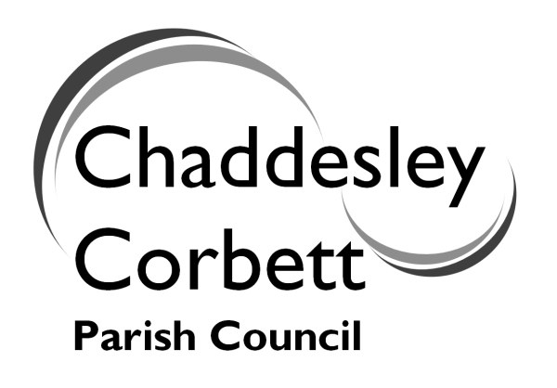 | ANNUAL PARISH MEETING  on  Wednesday 16 June 2010  at  7.00 for 7.30 p.m.  at  Chaddesley Corbett Village Hall
Refreshments from 7.00-7.30p.m.

AGENDA FOR MEETING

7.30 1. Welcome and Introductions Cllr Jonathan Swift

7.35 2. Police Inspector Paul and PC Jayne Willetts

7.45 3. Affordable Housing Cllr Jonathan Swift/Ken Bartlett

7.50 4. Parking in the Village Cllr Dave Thomas

7.55 5. Lengthsman Scheme Cllr Geoff Vernon

8.00 6. Annual Report/Emergency Planning
and Residents Handbook Cllr Jonathan Swift

8.05 7. Parish Games Mrs Hilary Boden

8.10 8. The Environment Group Mr Martin Kenrick

8.15 9. Neighbourhood Watch Cllr Jonathan Swift

8.20 10. Parish Footpaths Mrs Helen Jarrett

8.25 11. Allotments/Community
Orchard Cllr Leo Stockford

8.30 12. Burial Ground Cllr Ken Bartlett

8.35 13. Queen’s Diamond Jubilee Cllr J Swift

8.40 14. New School Mr Colin Emeny

8.50 15. Reports from District Councillor Cllr S Williams

8.55 16. Open Session

