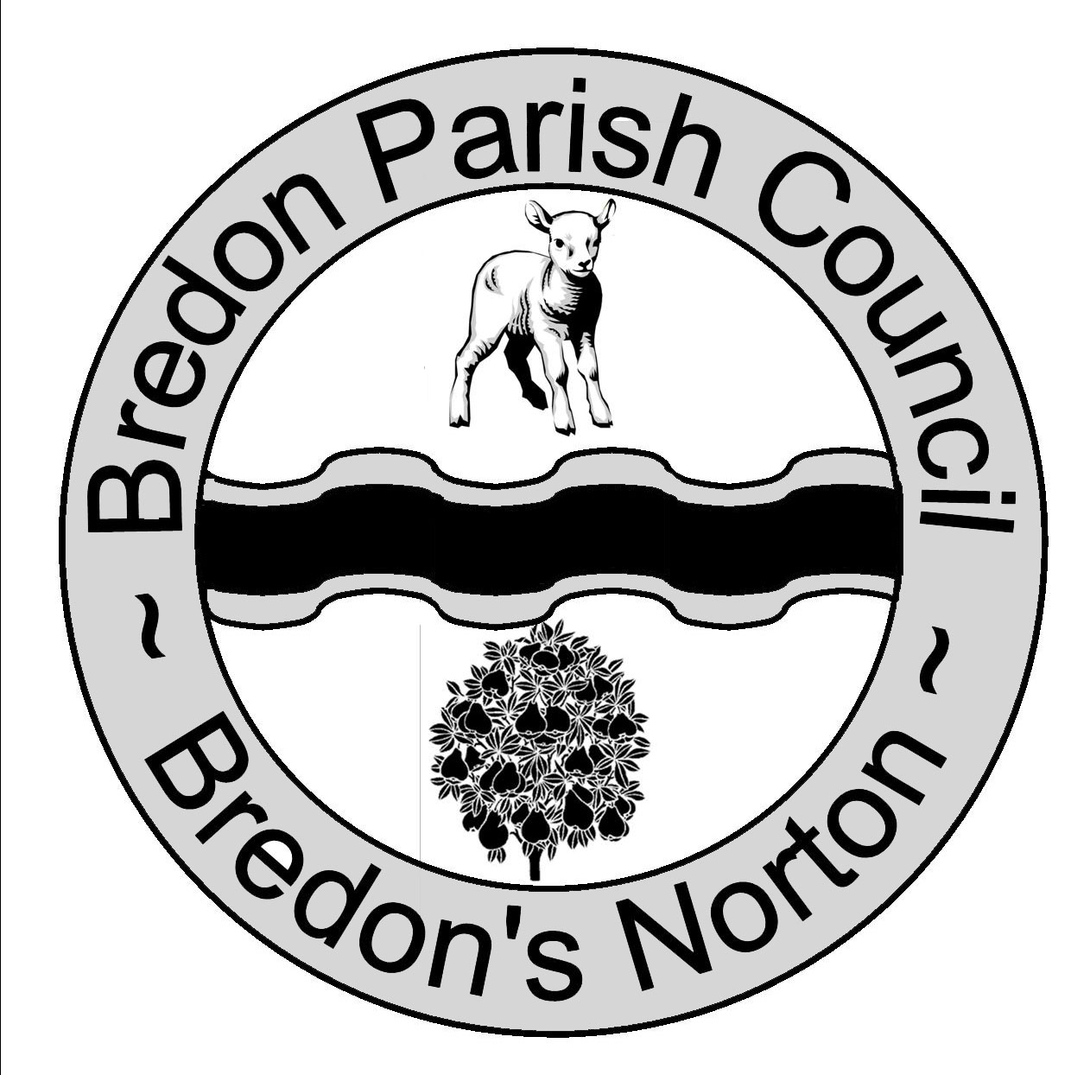 Chairman Mr K Brown Clerk Ms J Shields
Potenza
Chapel Lane
Kinsham
Nr Tewkesbury
Glos
GL20 8HS

Bredonpc@btinternet.com
www.bredonparishcouncil.org.uk

Bredon Parish Council is holding a meeting at Bredon Village Hall on Thursday 18th November 2010 at 8.15pm.

From 8.15pm residents are invited to give their views and to question the Parish Council on issues on the Agenda; additionally they can, at the discretion of the Chairman, raise issues for future consideration. There will be a time limited of 5 minutes per item and 15 minutes in total.

Members of the public may not take part in the Parish Council meeting itself but are welcome to attend.

AGENDA
- Apologies For Absence.

Declaration Of Interests.
- Register Of Interests.
Councillors are reminded of the need to update their register of interest.
- To Declare Any Personal Interest In Items On The Agenda And Their Nature.
- To Declare Any Prejudicial Interest In Items On The Agenda And Their Nature. (Councillors with prejudicial interests must leave the room during the relevant items)

- To Consider The Rugby Club Use Of The Village Hall.

- Items For Future Agenda.
Each councillor is requested to use this opportunity to report minor matters of information and to respectfully reminded councillors that this is not an opportunity for either debate or decision making.

- Date of Next Meeting.

