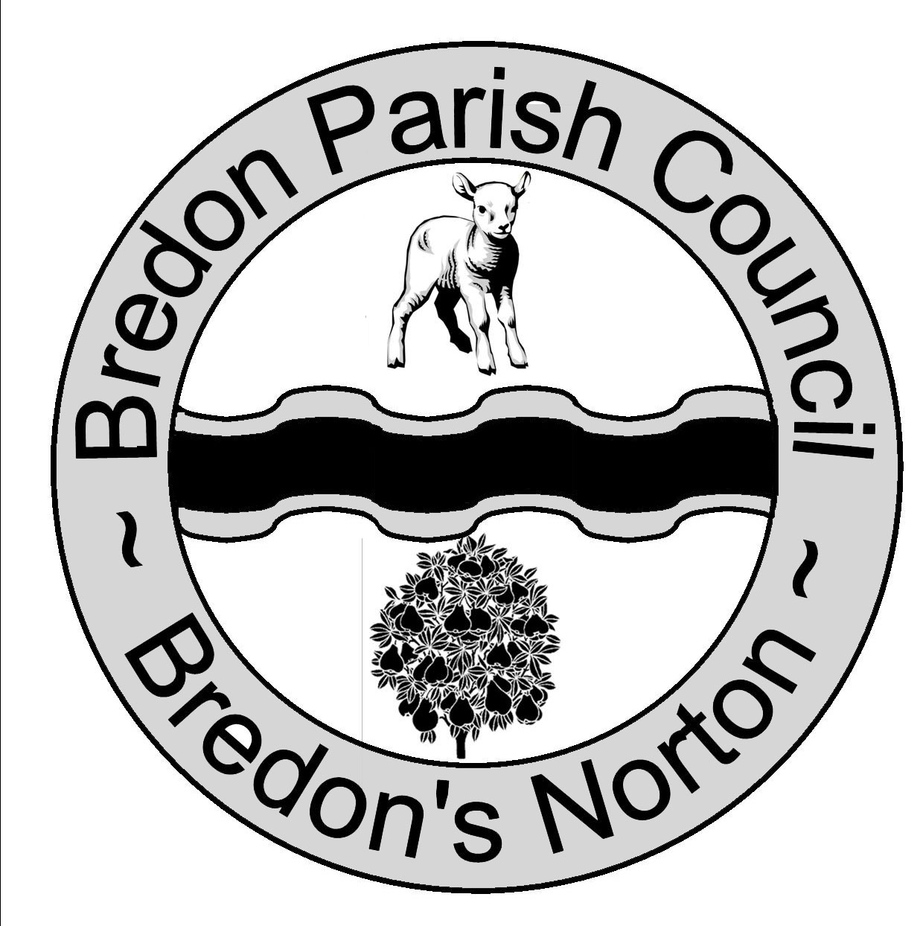 Chairman Mr K Brown Clerk Ms J Shields
Potenza
Chapel Lane
Kinsham
Nr Tewkesbury
Glos
GL20 8HS

Bredonpc@btinternet.com
Bredon Parish Council is holding a meeting at Bredon Village Hall on Monday on
Monday 13th December 2010 at 7.15pm.

From 7.15pm residents are invited to give their views and to question the Parish Council on issues on the Agenda; additionally they can, at the discretion of the Chairman, raise issues for future consideration. There will be a time limited of 5 minutes per item and 15 minutes in total.

Members of the public may not take part in the Parish Council meeting itself but are welcome to attend.
AGENDA
- Apologies For Absence.

Declaration Of Interests.
- Register Of Interests.
Councillors are reminded of the need to update their register of interest.
- To Declare Any Personal Interest In Items On The Agenda And Their Nature.
- To Declare Any Prejudicial Interest In Items On The Agenda And Their Nature. (Councillors with prejudicial interests must leave the room during the relevant items)
- To Consider The Adoption Of The Minutes Of The Meeting Held On The 8th and 13th November 2010.
- Correspondence For Information
- Finance
- Invoices To Be Paid.
- Financial Report.
- Progress Reports For Information.
- Clerk.
- Playing Field Support Group.
- BCPR.
- Bredon Village Hall Management Group.
- Bredons Norton Village Hall.
- Lengthsman.
- Clerks’ Finance Working Group.
- County and District Councillor.
- Bredon Hill Conservation Group.
- Parish Plan.
- Highways Issues.
- Motorway Noise
- Planning.
  - For Consideration.
  - Decided by Wychavon.
- To Appoint A Councillor To The Following Groups; Finance And Staff.
- To Update the Council on the Rugby Club And The Village Hall.
- Update On Rent Reviews.
- To Discuss Placing The Playing Fields In Trust.
- To Discuss Grass Cutting.
- To Consider a Litter Bin in Church Street.
- To Consider Lottery Funding for the Village Hall.
- Items For Future Agenda.
Each councillor is requested to use this opportunity to report minor matters of information not respectfully reminded that his is not an opportunity for either debate or decision making.
- Date of Next Meeting.

