PEBWORTH PARISH COUNCIL

To all Members of Pebworth Parish Council.
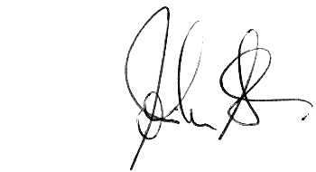
You are hereby summoned to an extraordinary meeting of the Parish Council to be held at the Village Hall on Friday 10th February 7:00 pm for transacting the following business only.
John Stedman: Clerk to the Council 30 July 2026
- Apologies:
To receive apologies and agree the reason for absence from:
- Disclosures of Interests
Register of Interests: Members are reminded of the need to keep their register up to date.
To declare and disclose any personal or prejudicial interests in items on the agenda.
Councillors with a prejudicial interest must leave the room for the relevant agenda item.
(Note: Members are reminded that the Code of Conduct provides that, if they have a prejudicial interest in any matter under discussion, then providing the matter is considered in public session, they are entitled to make representations and answer questions if members of the public are granted the same entitlement. Members must leave the room before any ensuing debate and vote and must not attempt to improperly influence a decision about that matter.)
- The Developers, Alan Smith Associates, to give a presentation on the Bank Farm planning application
- Chairman to Move: The meeting be now adjourned for Open Forum for 30 minutes
Open Forum: At the Chairman’s discretion residents are invited to give their views and question the Parish Council on issues on this agenda.
Members of the public may not take part in the Parish Council meeting. Brief notes on open forum may be appended to the minutes.
- Chairman to Move: The adjournment to close.
- Planning Applications for consideration –
  - W/11/00019/OU Mr Redfern- Bank Farm; Demolish farm buildings and construct 6 dwellings
- To confirm the next meeting date
The next Ordinary Meeting of the Council scheduled for 5th March at 7.00pm

End

