MADRESFIELD PARISH COUNCIL

NOTICE IS HEREBY GIVEN THAT THE FOLLOWING MEETINGS WILL TAKE PLACE ON THURSDAY 10TH MAY IN MADRESFIELD SCHOOL

119TH ANNUAL PARISH MEETING
Commencing at 7pm.

AGENDA
1. Apologies for absence
2. Approval of the minutes of the 118th Annual Parish Meeting of Monday 23rd May 2011
3. Reports to be presented:
i. Parish Council
ii. School
iii. Village Charities
iv. Footpaths Warden
v. Tree Warden
vi. Finance
4. Questions and comments from the public

TO BE FOLLOWED BY THE
ANNUAL & 178TH PARISH COUNCIL MEETING

AGENDA
1. Election of Chairman
2. Apologies for absence
3. Declarations of interest and changes to the register of interests.
4. Election of Wardens and other representatives
i. Footpaths Warden
ii. Tree Warden
iii. Charities Representative
5. Approval of minutes of 177th Parish Council Meeting of Monday 6th February 2012
6. Progress Reports and other matters arising from these minutes
7. Reports from District and County Councillors
8. Diamond Jubilee
To consider options to mark the event
9. Highways matters for report
10. Planning
- To consider responses to any late submitted applications
- To consider any response to the SWDP preferred options consultation
11. Finance
i. Approval of Annual Accounts
ii. Appointment of Internal Auditor
iii. Completion of ‘Annual Governance Statement’
iv. Approval of Payments due
12. Correspondence
To consider responses to correspondence received
13. Councillor’s items for report or for future consideration
14. Date of next meeting.

THE PUBLIC AND PRESS ARE INVITED TO ATTEND

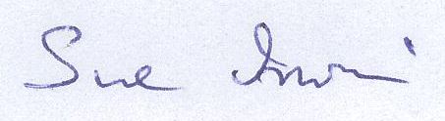

Chairman Madresfield Parish Council

Clerk: David Sharp, 20 Farley Road, Malvern, Worcestershire, WR14 1NF 30 April 2012
Telephone & Fax 01684 573213 dasharp@lineone.net

