KIDDERMINSTER FOREIGN PARISH COUNCIL
CHAIRMAN:
Councillor J. Gammond
Tel: 01299 400750
CLERK TO THE COUNCIL:
Mrs E. Whitehouse
Tel: 01299 861026

You are summoned to attend

A MEETING OF THE PARISH COUNCIL
to be held at

TRIMPLEY VILLAGE HALL
on
MONDAY 16th July 2012
at 7.45p.m.
(Please note date, venue and time of meeting)
Members of the public and
the press are welcome to attend.
The meeting will commence with a
PUBLIC LOCAL FORUM with planned attendance by West Mercia Constabulary officer
The Agenda for the Parish Council meeting is attached.

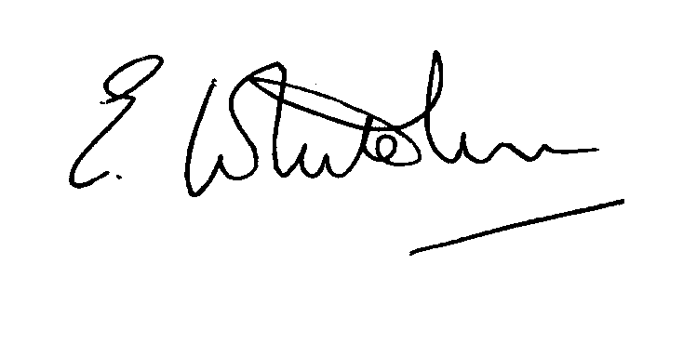

Dated: 9th July 2012 Clerk to the Council

e-mail: clerk.kiddfor.pc@googlemail.com

A G E N D A

(Note: The notation (I) indicates that the item is for information; (D) indicates that it requires a decision)

 | Apologies for Absence and Approval of Reasons.
 | Declarations of Interest.
 | Approval of the Minutes of the Annual Meeting held 18th June 2012 |  | Enclosure 1
 | Planning and Development Control.
 | a. | Applications previously considered  Update | (I)
 | b. | Applications received up to date of meeting - inc  12/0396 Demolish existing chalet and replace with a timber framed bungalow at Sunnyside, Hill Farm, Bewdley  12/0402 – Conversion of Barn into 3-Bedroom dwelling at The Riddings, Crundalls Lane, Bewdley (Renewal of planning permission 09/0699) | (D)
 | c. | Compliance Issues  Update | (I)
 | Progress Reports / Matters Arising
 | a.  b.  c.  d.  e. | Highway Matters  Siting of Jubilee Benches  Memorial to Mr. K. Briggs  Repairs to Noticeboards  Broadband for Trimpley Village Hall | (I) & (D)
6. | Newsletter – for distribution
7. | Code of Conduct and Declarations of Interest |  | (D)
8. | Lengthsman  - Tabling of any invoice for work undertaken |  | (D)
9. | Financial Reports and Payment of Accounts.
 | a. | Payments  Any payment due to Lengthsman  Chairman’s Allowance  Clerk’s Expenses | (D)
 | b. | Bank Reconciliation | (I)
10. | Worcestershire CALC Reports and Notices |  | (I)
11. | County and District Council Matters and Other Correspondence, inc:
12. | Any report from the County or District Councillor representatives not already tabled
13. | Road Accident Record
14. | Other matters which the Chairman, after consulting members, feels to be of an urgent nature
15. | Next Meeting: confirmation : Monday 20th August 2012 – 7.45p.m.  at Trimpley Village Hall |  | .

