KIDDERMINSTER FOREIGN PARISH COUNCIL
CHAIRMAN:
Councillor J. Gammond
Tel: 01299 400750
CLERK TO THE COUNCIL:
Mrs E. Whitehouse
Tel: 01299 861026

You are summoned to attend

A MEETING OF THE PARISH COUNCIL
to be held at

TRIMPLEY VILLAGE HALL
on
MONDAY 18th March 2013
at 7.45p.m.
(Please note date, venue and time of meeting)
Members of the public and
the press are welcome to attend.
The meeting will commence with a
PUBLIC LOCAL FORUM with planned attendance by West Mercia Constabulary officer
The Agenda for the Parish Council meeting is attached.

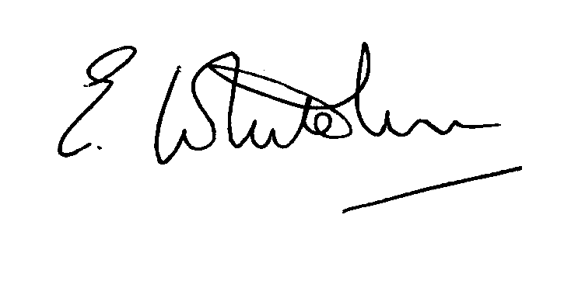

Dated: 11th March 2013 Clerk to the Council

e-mail: clerk.kiddfor.pc@googlemail.com

A G E N D A

(Note: The notation (I) indicates that the item is for information; (D) indicates that it requires a decision)

 | Apologies for Absence and Approval of Reasons.
 | Declarations of Interest.
 | Approval of the Minutes of the Parish Council Meeting held 11th February 2013 |  | Enclosure 1
 | Planning and Development Control.
 | a. | Applications previously considered  Update | (I)
 | b. | Applications received up to date of meeting - inc: any received up to date of meeting, inc:  13/0100/CERTE Proposal: Certificate of lawfulness: Use of property for full occupation for more than 4 years  Site: THE RAMILIES HILL FARM, NORTHWOOD LANE, BEWDLEY, DY121AT | (D)
 | c. | Compliance Issues  Update – if any, | (I)
 | Progress Reports / Matters Arising
 | a.  b.  c. | Highway Matters – as previously discussed  Lightmarsh Anti-Flooding Scheme  Discussion to take place on positioning of signs on approach from Kidderminster to Trimpley Crossroads
6. | Lengthsman  - Tabling of any invoice for work undertaken  - General discussion on work undertaken  - VA Sign installation and training |  | (D)
7. | Financial Reports and Payment of Accounts.
 | a. | Payments  Any invoice tabled by the Lengthsman  Clerk’s Expenses  Clerk’s Salary  PAYE  Village Hall – Room Rental  Ditching Eymore Lane | (D)
 | b. | Consideration of Request from Arley School re Grant towards transporting Children to swimming
 | c. | Confirmation of Internal Auditor
 | d. | Details of RTI on PAYE
8. | Worcestershire CALC Reports and Notices |  | (I)
9. | County and District Council Matters and Other Correspondence.
10. | Any report from the County or District Councillor representatives not already tabled
11. | Road Accident Record
12. | Items for Next Newsletter (Inc. Photos)
13. | Other matters which the Chairman, after consulting members, feels to be of an urgent nature
14. | Next Meeting: confirmation : Annual General Assembly Monday 15th April 2013 – Time to be confirmed  at Trimpley Village Hall |  | .

