West Malvern Annual Parish Meeting

At 7.00pm on Monday 8th April 2013 in West Malvern Village Hall

AGENDA

1) Introduction by the Chairman

2) Apologies for Absence

3) Approval of the Minutes of the Annual Parish Meeting held on 14th May 2012

4) Presentation by Nick Hands from The Malvern Hills Outdoor Education Centre.

5) Presentation by Nathan Burlton from the Colwall Car Club.

- County & District Councillors’ Reports

7) Parish Council Reports
- Chairman’s Report
- Tree Wardens’ Report
- Parish Paths Warden’s Report
- Clerk’s Financial Report

8) Questions and comments from the floor regarding other parish matters

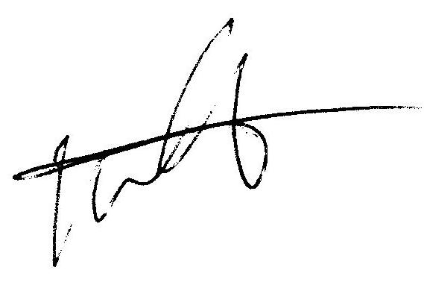
Bill Shearer
Chairman West Malvern Parish Council

