KIDDERMINSTER FOREIGN PARISH COUNCIL
CHAIRMAN:
Councillor J. Gammond
Tel: 01299 400750
CLERK TO THE COUNCIL:
Mrs E. Whitehouse
Tel: 01299 861026

You are summoned to attend
A PACT MEETING
(Police & Community Together)
FOR ARLEY, SHATTERFORD & BEWDLEY At 7p.m.
followed by

THE ANNUAL PARISH ASSEMBLY
to be held at

TRIMPLEY VILLAGE HALL
MONDAY 15th April 2013 at 7.40pm
(Please note date, venue and time of meeting)
Members of the public and
the press are welcome to attend.
This will be followed by a
PARISH COUNCIL MEETING
The Agenda for the Annual Parish Assembly and The Parish Council meeting is attached.
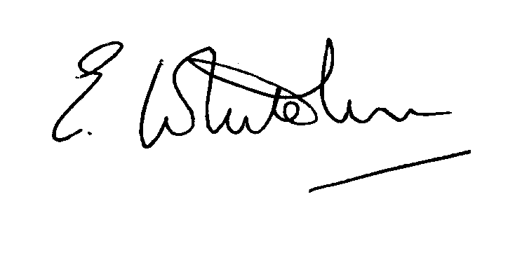

Dated: 7th April 2013 Clerk to the Council

e-mail: clerk.kiddfor.pc@googlemail.com

PACT MEETING FOR ARLEY, SHATTERFORD AND TRIMPLEY @ 7PM
Followed by
THE ANNUAL PARISH ASSEMBLY
AGENDA

- Apologies
- Any items raised by the Public present (all items to be raised through the Chair)
- Any other matters for the Parish Assembly
Followed by
PARISH COUNCIL MEETING
AGENDA

(Note: The notation (I) indicates that the item is for information; (D) indicates that it requires a decision)

 | Apologies for Absence and Approval of Reasons.
 | Declarations of Interest.
 | Approval of the Minutes of the Parish Council Meeting held 18th March 2013 |  | Enclosure 1
 | Planning and Development Control.
 | a. | Applications previously considered  Update | (I)
 | b. | Applications received up to date of meeting - inc: any received up to date of meeting, inc:  WF 13/0157 Certificate of Lawfulness  THE CREST, RICKYARD MEADOW, NORTHWOOD LANE, BEWDLEY, DY121AT | (D)
 | c. | Compliance Issues  Update – if any, | (I)
 | Progress Reports / Matters Arising
 | a. | Highway Matters – as previously discussed
6. | Lengthsman  - Tabling of any invoice for work undertaken  - Lengthsman’s contract |  | (D)
7. | Newsletter
8. | Financial Reports and Payment of Accounts.
 | a.  b. | Payments  Clerk’s Salary – Schedule for Standing Order Monthly Payment  PAYE – Schedule for Standing Order Monthly Payment  Confirmation of Asset List and Risk Assessment | (D)
 | c. | Approval of End of Year Accounts and Bank Reconciliation in preparation for the Internal Audit
 | d. | Notices re Audit – for posting in the parish
9. | Worcestershire CALC Reports and Notices |  | (I)
10. | County and District Council Matters and Other Correspondence.
11. | Any report from the County or District Councillor representatives not already tabled
12. | Road Accident Record
13. | Other matters which the Chairman, after consulting members, feels to be of an urgent nature
14. | Next Meeting: confirmation : Annual General Meeting - Monday 20th May 2013 – at Trimpley Village Hall |  | .

