Bredon, Bredon’s Norton and Westmancote Parish Council
Bredon Village Hall
Main Road
Bredon
Nr Tewkesbury
Glos
GL20 7QN
01684 773984
Bredonpc@btconnect.com
.com

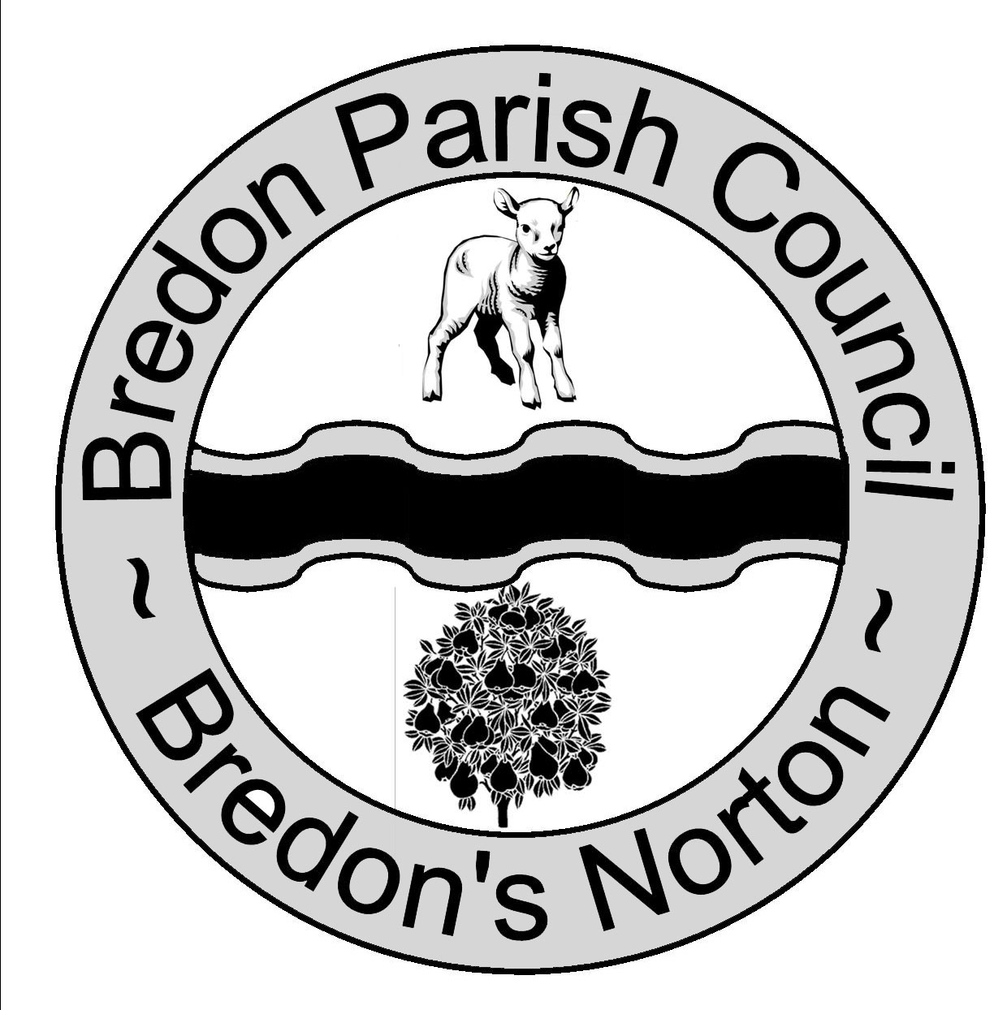 Chairman Mr A Woodward Clerk Ms J Shields

Bredon Parish Council is holding a meeting at Bredon Village Hall on Monday 1st July 2013 at 7.15pm.

Residents are invited to give their views and to question the Parish Council on issues on the Agenda; additionally they can, at the discretion of the Chairman, raise issues for future consideration. There will be a time limited of 5 minutes per item and 15 minutes in total.

Members of the public may not take part in the Parish Council meeting itself but are welcome to attend. Bredon Parish Council is holding a meeting at Bredon Village Hall on Monday 1st July 2013 at 7.15pm.

AGENDA

- Apologies For Absence.
- Declaration of Interests.
- Register of Interests: Councillors are reminded of the need to update their register of interests.
- To declare any Disclosable Pecuniary Interests in items on the agenda and their nature.
- To declare any Other Disclosable Interests in items on the agenda and their nature.
Councillors who have declared a Disclosable Pecuniary Interest, or an Other Disclosable Interest which falls within the terms of paragraph 12(4) (b) of the code of conduct, must leave the room for the relevant items.
Failure to register or declare a Disclosable Pecuniary Interest may result in the commission of a criminal offence.
- To Consider Application for Dispensation.
- To Consider The Adoption Of The Minutes Of The Meeting Held On The 3rd June 2013.
- Planning Application at Bensham Fields.

Meeting adjourned
to allow Members of the Public to express views.
Meeting reconvened

Discuss Planning Application At Bensham Fields.
- To Discuss New Homes Bonus Applications.
- Finances.
- Invoices to Be Paid.
- Financial Report.
- Planning.
- For Consideration.
- Decided By Wychavon.
- To Discuss Possible Development in Oak Lane.
- Correspondence for Information.
- Progress Reports For Information.
- Clerk.
- Bredon Village Hall.
- Bredons Norton Village Hall.
- County and District Councillor.
- Defibrillator.
- HFN and the Skate Equipment.
- Rural Broadband
- Parish Magazine.
- Councillors Reports and Items For Future Agenda.
Each councillor is requested to use this opportunity to report minor matters of information not included elsewhere on the agenda and to raise items for future agendas. Councillors are respectfully reminded that this is not an opportunity for debate or decision making.
- Date Of Next Meeting.

