KIDDERMINSTER FOREIGN PARISH COUNCIL
CHAIRMAN:
Councillor B. Phillips
Tel: 01299 861419
CLERK TO THE COUNCIL:
Mrs E. Whitehouse
Tel: 01299 861026

You are summoned to attend

A MEETING OF THE PARISH COUNCIL
to be held at

TRIMPLEY VILLAGE HALL
on
MONDAY 15th July 2013
at 7.45p.m.
(Please note date, venue and time of meeting)
Members of the public and
the press are welcome to attend.
The meeting will commence with a
PUBLIC LOCAL FORUM with planned attendance by West Mercia Constabulary officer
The Agenda for the Parish Council meeting is attached.

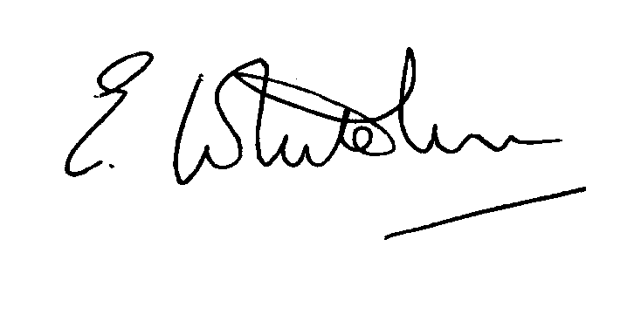

Dated: 7th July 2013 Clerk to the Council

e-mail: clerk.kiddfor.pc@googlemail.com

A G E N D A

(Note: The notation (I) indicates that the item is for information; (D) indicates that it requires a decision)

 | Apologies for Absence and Approval of Reasons.
 | Discussion with guest Mr. D. Hunter, Highways Engineer |  | (I)
 | Declarations of Interest.
 | Approval of the Minutes of the Meeting of the Parish Council held 10th June 2013 |  | Enclosure 1
 | Planning and Development Control.
 | a. | Applications previously considered  Update | (I)
 | b. | Applications received up to date of meeting - inc:  13/0307 Construction of detached garages at CROFTON LODGE, TRIMPLEY, BEWDLEY, DY121NL.  13/0320 Reconstruction of Roof Structure to form Additional Accommodation at HIGH ACRE, TRIMPLEY, BEWDLEY, DY121NG | (D)  (D)
 | c. | Compliance Issues  Update. | (I)
 | Progress Reports / Matters Arising – inc. Highway matters
6. | Items for Newsletter
7. | Lengthsman  - Tabling of any invoice for work undertaken |  | (D)
8. | Newsletter – Distribution
9. | Financial Reports and Payment of Accounts.
 | a. | Payments  Any invoice tabled by the Lengthsman  PAYE re Clerk  Insurance premium supplement re VA Sign | (D)
10. | Worcestershire CALC Reports and Notices |  | (I)
11. | County and District Council Matters and Other Correspondence.
12. | Any report from the County or District Councillor representatives not already tabled
13. | Road Accident Record
14. | Other matters which the Chairman, after consulting members, feels to be of an urgent nature
16. | Next Meeting: confirmation : Monday 15th July 2013 – 7.45p.m.  at Trimpley Village Hall |  | .

