Little Malvern & Welland Parish Council

NOTICE OF A PARISH COUNCIL MEETING TO BE HELD ON
MONDAY 19th AUGUST 2013 AT 7.30PM IN THE WELLAND PARISH HALL

Before the start of the meeting residents are invited to give their views and questions on issues on the agenda, or raise ISSUES FOR FUTURE CONSIDERATION.

AGENDA
1. APOLOGIES
To consider acceptance of apologies for absence from Councillor:

2. INTERESTS
i. Councillors Declarations of Disclosable Pecuniary Interests and Other Disclosable Interests regarding items on the agenda.
ii. Notification of changes to the register of interests.
iii. To consider written requests from councillors for the council to grant a dispensation for those with Disclosable Interests to take part in discussions or voting:

- MINUTES
To consider for adoption the minutes of the last Parish Council meeting held on 15th July:

4. PROGRESS REPORTS AND OTHER MATTERS ARISING FROM THESE MINUTES

5. REPORTS BY DISTRICT AND COUNTY COUNCILORS AND OTHER REPRESENTATIVES

6. COMMITTEE & WORKING PARTY REPORTS & RECOMMENDATIONS
- Neighbourhood Planning Group:
- Playing Fields:

7. PLANNING
i To consider responses to the following and any late submitted applications:
Application No | From | Details
13/00829/HOU | Mr & Mrs P Loader  The Willows, Hook Bank | 2 storey rear extension
ii Decisions notified

8. HIGHWAYS & FOOTPATHS
Items for report or consideration

9. CORRESPONDENCE
See agenda notes

10. FINANCE
- To consider payment of invoices presented

11. ANY OTHER MATTERS FOR REPORT OR FOR FUTURE CONSIDERATION

12. DATE OF NEXT MEETING
Monday 16th September 2013

THE PUBLIC AND PRESS ARE INVITED TO ATTEND

11 June 2013
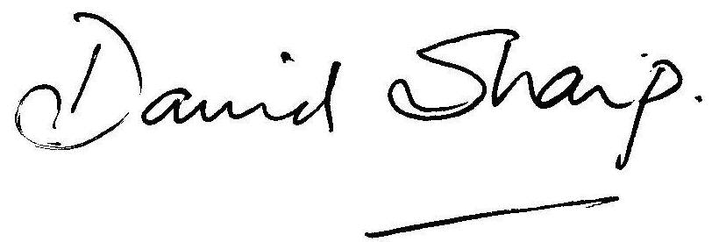

David Sharp Clerk to the Parish Council

