KIDDERMINSTER FOREIGN PARISH COUNCIL
CHAIRMAN:
Councillor B. Phillips
Tel: 01299 861419
CLERK TO THE COUNCIL:
Mrs E. Whitehouse
Tel: 01299 861026

You are summoned to attend

A MEETING OF THE PARISH COUNCIL
to be held at

TRIMPLEY VILLAGE HALL
on
MONDAY 21st October 2013
at 7.45p.m.
(Please note date, venue and time of meeting)
Members of the public and
the press are welcome to attend.
The meeting will commence with a
PUBLIC LOCAL FORUM with planned attendance by West Mercia Constabulary officer
The Agenda for the Parish Council meeting is attached.

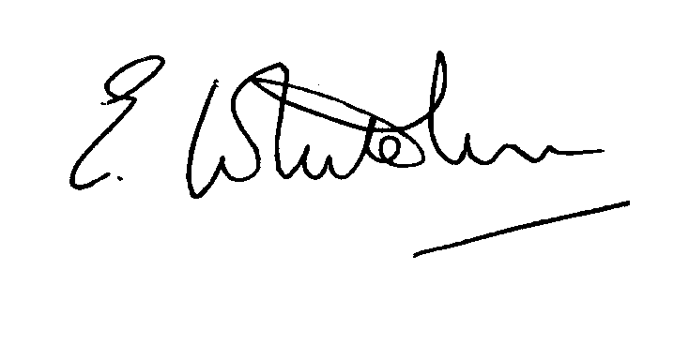

Dated: 12th October 2013 Clerk to the Council

e-mail: clerk.kiddfor.pc@googlemail.com

A G E N D A

(Note: The notation (I) indicates that the item is for information; (D) indicates that it requires a decision)

 | Police Report and Public Local Forum
 | Apologies for Absence and Approval of Reasons.
 | Declarations of Interest.
 | Approval of the Minutes of the Meeting of the Parish Council held 16th September 2013 |  | Enclosure 1
 | Planning and Development Control.
 | a. | Applications previously considered  Update | (I)
 | b. | Applications received up to date of meeting - Inc:  13/0496 : Proposed garage and log store, alterations to existing store to create study and brick paving to part of existing courtyard at THE THRESHING BARN, LIGHT MARSH FARM, CRUNDALLS LANE, BEWDLEY, DY121NE  13/0504 Conversion of existing agricultural building to No. 4 bed dwelling with attached garaging; Demolition of redundant structure at TRIMPLEY GREEN FARM, TRIMPLEY, BEWDLEY, DY121NR. | (D)  (D)
 | c. | Compliance Issues  Update. | (I)
Progress Reports / Matters Arising – inc. Highway matters
Car Parking issues – Low Habberley ) if not already dealt with under
Car Dumped at Eymore Lane Car Park ) discussion with the police
 | Severn Trent Matters, including:-  Car Park and Vehicle issues at Eymore  Recurrent water pipe failures – Shatterford Lane (Myndholm vicinity) |  | (I)
8. | Newsletter
9. | Lengthsman  - Tabling of invoices for work undertaken |  | (D)
10. | Financial Reports and Payment of Accounts.
 |  | Payments  Any invoice tabled by the Lengthsman  PAYE re Clerk  Archaeology Dayschool – attendance fee | (D)
11. | Casual Vacancy – procedure details summary from Clerk |  | (I)
12. | Worcestershire CALC Reports and Notices |  | (I)
13. | County and District Council Matters and Other Correspondence.
14. | Any report from the County or District Councillor representatives not already tabled
15. | Road Accident Record
16. | Other matters which the Chairman, after consulting members, feels to be of an urgent nature
17. | Next Meeting: confirmation : Monday 18th November 2013 – 7.45p.m.  at Trimpley Village Hall |  | .

