Little Malvern & Welland Parish Council

NOTICE OF A PARISH COUNCIL MEETING TO BE HELD ON
MONDAY 16th SEPTEMBER 2013 AT 7.30PM IN THE WELLAND PARISH HALL

Before the start of the meeting residents are invited to give their views and questions on issues on the agenda, or raise ISSUES FOR FUTURE CONSIDERATION.

AGENDA
1. APOLOGIES
To consider acceptance of apologies for absence from Councillor:

2. INTERESTS
i. Councillors Declarations of Disclosable Pecuniary Interests and Other Disclosable Interests regarding items on the agenda.
ii. Notification of changes to the register of interests.
iii. To consider written requests from councillors for the council to grant a dispensation for those with Disclosable Interests to take part in discussions or voting:

- MINUTES
To consider for adoption the minutes of the last Parish Council meeting held on 19th August:

4. PROGRESS REPORTS AND OTHER MATTERS ARISING FROM THESE MINUTES

5. REPORTS BY DISTRICT AND COUNTY COUNCILORS AND OTHER REPRESENTATIVES

6. COMMITTEE & WORKING PARTY REPORTS & RECOMMENDATIONS
- Neighbourhood Planning Group:
- Playing Fields:

7. PLANNING
i To consider responses to the following and any late submitted applications:
Application No | From | Details
13/00995/HOU | Mr & Mrs C Cox  Hanley Hall, Gilbert's End | Construction of a single storey extension and associated landscape works. Internal and external repairs and alterations.
ii Decisions notified
iii. To consider options available when printed plans of applications are no longer available from October.

8. HIGHWAYS & FOOTPATHS
Items for report or consideration

9. RATE RELIEF
To consider and application for Rural Rate Relief from The Stores, Gloucester Road

10. CAR BOOT SALES
To consider recommendations to the change in the way car boots are run in 2014

11. CORRESPONDENCE
See agenda notes

12. FINANCE
To consider payment of invoices presented

13. ANY OTHER MATTERS FOR REPORT OR FOR FUTURE CONSIDERATION

14. DATE OF NEXT MEETING
Monday 21st October 2013
THE PUBLIC AND PRESS ARE INVITED TO ATTEND
10/09/13
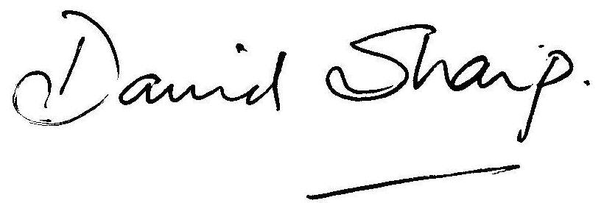

David Sharp Clerk to the Parish Council

