Little Malvern & Welland Parish Council

NOTICE OF A PARISH COUNCIL MEETING TO BE HELD ON
MONDAY 21st OCTOBER 2013 AT 7.30PM IN THE WELLAND PARISH HALL

Before the start of the meeting residents are invited to give their views and questions on issues on the agenda, or raise ISSUES FOR FUTURE CONSIDERATION.

AGENDA
1. APOLOGIES
To consider acceptance of apologies for absence from Councillor:

2. INTERESTS
i. Councillors Declarations of Disclosable Pecuniary Interests and Other Disclosable Interests regarding items on the agenda.
ii. Notification of changes to the register of interests.
iii. To consider written requests from councillors for the council to grant a dispensation for those with Disclosable Interests to take part in discussions or voting:

- MINUTES
To consider for adoption the minutes of the last Parish Council meeting held on 16th September:

4. PROGRESS REPORTS AND OTHER MATTERS ARISING FROM THESE MINUTES

5. REPORTS BY DISTRICT AND COUNTY COUNCILORS AND OTHER REPRESENTATIVES

6. COMMITTEE & WORKING PARTY REPORTS & RECOMMENDATIONS
- Neighbourhood Planning Group:
- Playing Fields:

7. PLANNING
i To consider responses to the following and any late submitted applications:
Application No | From | Details
13/01204/S73 | HDS Homes  Bellevue, Gloucester Rd | Variation on condition 1 of planning permission 13/00511/FUL to alter parking arrangements
13/01260/HOU | Mr J Cockburn  2 The Old Dairy | Single storey extension
13/00320/FUL | Mr & Mrs Kenzie  Merebrook Farm | Change of use and conversion of existing building to holiday let unit
ii Decisions notified
iii. To review costings for a projector to display planning applications and approve purchase.

8. HIGHWAYS & FOOTPATHS
To consider repair/replacement of battery operated Vehicle Activated Sign.

9. CORRESPONDENCE
See agenda notes

10. FINANCE
To consider payment of invoices presented

11. ANY OTHER MATTERS FOR REPORT OR FOR FUTURE CONSIDERATION

12. DATE OF NEXT MEETING
Monday 18th November 2013

THE PUBLIC AND PRESS ARE INVITED TO ATTEND

15/10/13
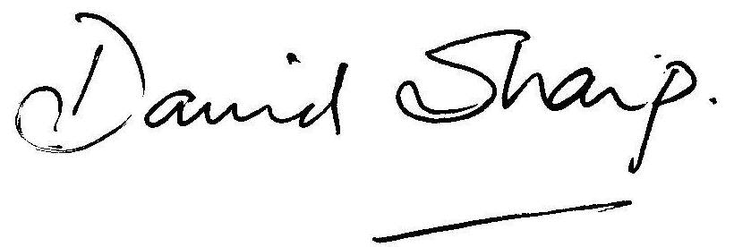

David Sharp Clerk to the Parish Council

