Little Malvern & Welland Parish Council

NOTICE OF A PARISH COUNCIL MEETING TO BE HELD ON
MONDAY 18th NOVEMBER 2013 AT 7.30PM IN THE WELLAND PARISH HALL

Before the start of the meeting residents are invited to give their views and questions on issues on the agenda, or raise ISSUES FOR FUTURE CONSIDERATION.

AGENDA

1. APOLOGIES
To consider acceptance of apologies for absence from Councillor:

2. INTERESTS
i. Councillors Declarations of Disclosable Pecuniary Interests and Other Disclosable Interests regarding items on the agenda.
ii. Notification of changes to the register of interests.
iii. To consider written requests from councillors for the council to grant a dispensation for those with Disclosable Interests to take part in discussions or voting.

- MINUTES
To consider for adoption the minutes of the last Parish Council meeting held on 21st October.

4. PROGRESS REPORTS AND OTHER MATTERS ARISING FROM THESE MINUTES

5. REPORTS BY DISTRICT AND COUNTY COUNCILORS AND OTHER REPRESENTATIVES

6. COMMITTEE & WORKING PARTY REPORTS & RECOMMENDATIONS
- Neighbourhood Planning Group:
- Playing Fields:

7. PLANNING
i To consider responses to the following and any late submitted applications:
Application No | From | Details
13/01344/FUL | Mr J Cockburn, Tyre Hill House | Provision of all-weather surface to existing riding gallops. (Retrospective)
ii To consider making representation at the appeal hearing for application 12/01087/OUT (Lawn Farm).
iii To consider arranging a public meeting to discuss application 13/01388/FUL (24 dwellings Off Marlbank Road).
iii Decisions notified.

8. HIGHWAYS & FOOTPATHS
To consider making recommendations regarding safety issues on the B438 from Welland to Rye Cross.

9. CORRESPONDENCE
See agenda notes.

10. FINANCE
To consider payment of invoices presented.

11. ANY OTHER MATTERS FOR REPORT OR FOR FUTURE CONSIDERATION

12. DATE OF NEXT MEETING
Monday 16th December 2013

THE PUBLIC AND PRESS ARE INVITED TO ATTEND

12/11/13
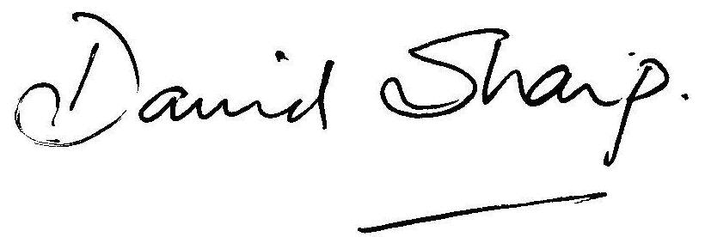

David Sharp Clerk to the Parish Council

