Little Malvern & Welland Parish Council

NOTICE OF A PARISH COUNCIL MEETING TO BE HELD ON
MONDAY 16th DECEMBER 2013 AT 7.30PM IN THE WELLAND PARISH HALL

Before the start of the meeting residents are invited to give their views and questions on issues on the agenda, or raise ISSUES FOR FUTURE CONSIDERATION.

AGENDA
1. APOLOGIES
To consider acceptance of apologies for absence from Councillor:

2. INTERESTS
i. Councillors Declarations of Disclosable Pecuniary Interests and Other Disclosable Interests regarding items on the agenda.
ii. Notification of changes to the register of interests.
iii. To consider written requests from councillors for the council to grant a dispensation for those with Disclosable Interests to take part in discussions or voting.

- MINUTES
To consider for adoption the minutes of the last Parish Council meeting held on 18th November.

4. PROGRESS REPORTS AND OTHER MATTERS ARISING FROM THESE MINUTES

5. REPORTS BY DISTRICT AND COUNTY COUNCILORS AND OTHER REPRESENTATIVES

6. COMMITTEE & WORKING PARTY REPORTS & RECOMMENDATIONS
- Neighbourhood Planning Group:
- Playing Fields:

- NEIGHBOURHOOD PLAN
To consider whether proceed with a Neighbourhood Plan and to apply to MHDC for Neighbourhood Area Status as recommended by the Working Group.

8. PLANNING
i To consider responses to the following and any late submitted applications:
Application No | From | Details
13/01388/FUL | DB Land & Planning  Land at OS79514008 Marlbank | Erection of 24 dwellings including 12 market and 12 affordable homes.
13/01363/FUL | Mrs Mary E Purser  The Tallet, Gloucester Road | Change of use from holiday let to residential dwelling
13/01560/FUL | Rachel Tattersall  Myrtle Cottage, Drake Street | Extension to existing barn for storage of hay and straw. Putting in new agricultural access
13/01113/HOU | Miss H Maddock  12 Chestnut Close | Two storey rear extension.
ii Decisions notified.

9. HIGHWAYS & FOOTPATHS
Matters for report and consideration

10. BUS SERVICES
To consider a response to the WCC Subsidised Bus Service Review

11. CORRESPONDENCE
See agenda notes.

12. FINANCE
i. To consider reports from auditors regarding the accounts for 2012/13 and to consider the effectiveness of the internal audit.
ii. To consider payment of invoices presented

13. ANY OTHER MATTERS FOR REPORT OR FOR FUTURE CONSIDERATION

14. DATE OF NEXT MEETING
Monday 20th January 2014

THE PUBLIC AND PRESS ARE INVITED TO ATTEND
10/12/13
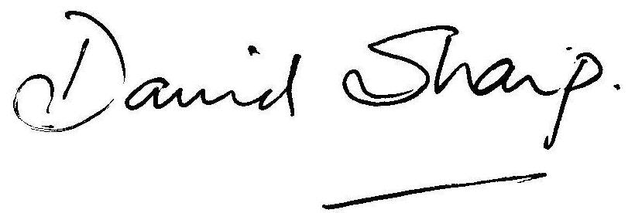

David Sharp, Clerk to the Parish Council

