KIDDERMINSTER FOREIGN PARISH COUNCIL
CHAIRMAN:
Councillor B. Phillips
Tel: 01299 861419
CLERK TO THE COUNCIL:
Mrs E. Whitehouse
Tel: 01299 861026

You are summoned to attend

A MEETING OF THE PARISH COUNCIL
to be held at

TRIMPLEY VILLAGE HALL
on
MONDAY 20th January 2014
at 7.45p.m.
(Please note date, venue and time of meeting)
Members of the public and
the press are welcome to attend.
The meeting will commence with a
PUBLIC LOCAL FORUM with planned attendance by West Mercia Constabulary officer
The Agenda for the Parish Council meeting is attached.

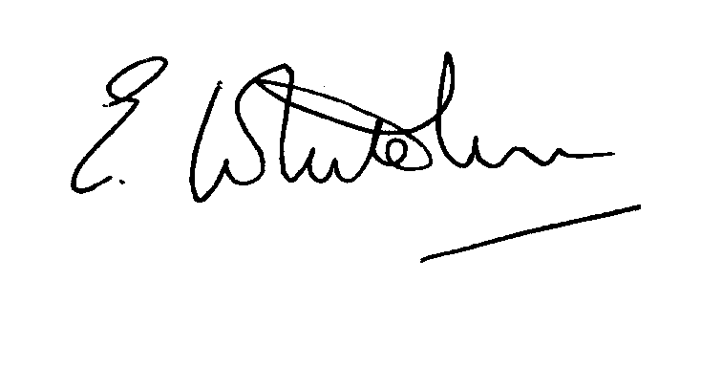

Dated: 11th January 2014 Clerk to the Council

e-mail: clerk.kiddfor.pc@googlemail.com

A G E N D A

(Note: The notation (I) indicates that the item is for information; (D) indicates that it requires a decision)

 | Police Report and Public Local Forum
 | Apologies for Absence and Approval of Reasons.
 | Declarations of Interest.
 | Approval of the Minutes of the Meeting of the Parish Council held 16th December 2013 |  | Enclosure 1
 | Planning and Development Control.
 | a. | Applications received up to date of meeting -  None as at date of Agenda | (D)
 | b. | Compliance Issues  Update. | (I)
Progress Reports / Matters Arising – inc. Highway matters
Flooding issues at Low Habberley
Footpath flooding – Trimpley Green.
Marsh – Trimpley Green
Grit Bins
Reflector post – Viewpoint.
 | Severn Trent Matters, including:-  Car Park at Eymore |  | (I)
 | Newsletter – Distribution discussion.
9. | Lengthsman  - Training re VA Sign battery change.  - Tabling of invoice for work undertaken. |  | (D)
10. | Financial Reports and Payment of Accounts.
 | a)  b) | Payments  Invoice tabled by the Lengthsman  Lettering for Honour Board.  PAYE re Clerk  Precept Setting and Demand for 2014-15  - Reference to be made to District Council guidance, and Accounts tabled at the December meeting. | (D)  (D)
11. | Worcestershire CALC Reports and Notices |  | (I)
12. | County and District Council Matters and Other Correspondence.  - Parish Games Quiz night  - Western Power Distribution Business Plan for 2015-2023 |  | (D)  (I)
13. | Any report from the County or District Councillor representatives not already tabled
14. | Road Accident Record
15. | Other matters which the Chairman, after consulting members, feels to be of an urgent nature
16. | Next Meeting: confirmation : Monday 24th February* at 7.45p.m.  at Trimpley Village Hall  (*Note – Change requested from 17th February) |  | .

