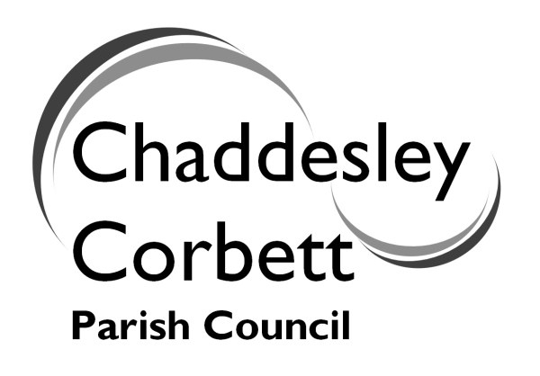 | You are invited to attend  the  ANNUAL PARISH MEETING  on  Wednesday 20 May 2009  at  7.00 for 7.30 p.m.  at  Chaddesley Corbett Village Hall
Refreshments from 7.00-7.30p.m.

AGENDA FOR MEETING

1. Police and PACT Meetings

2. Parking in the Village Cllr Dave Thomas

3. New School Trustee

4. Local Development Framework Rebecca Mayman
Wyre Forest District Council Wyre Forest District Council

5. Lengthsman Scheme Cllr Geoff Vernon

6. Environmental Group Mr Tom Westley

7. Affordable Housing Cllr Ken Bartlett

8. Bus Service Cllr Dave Thomas

9. Emergency Plan Cllr Jonathan Swift

10. Communication and
Neigbourhood Watch Cllr Jonathan Swift

11. Fair Trade Cllr Jonathan Swift

12. Allotments/Community
Orchard Cllr Leo Stockford

13. Burial Ground Cllr Ken Bartlett

14. Reports from District and County Councillors

15. Open Session

