Little Malvern & Welland Parish Council

NOTICE OF A PARISH COUNCIL MEETING TO BE HELD ON
MONDAY 20th JANUARY 2014 AT 7.30PM IN THE WELLAND PARISH HALL

Before the start of the meeting residents are invited to give their views and questions on issues on the agenda, or raise ISSUES FOR FUTURE CONSIDERATION.

AGENDA
1. APOLOGIES
To consider acceptance of apologies for absence from Councillors.

2. INTERESTS
i. Councillors Declarations of Disclosable Pecuniary Interests and Other Disclosable Interests regarding items on the agenda.
ii. Notification of changes to the register of interests.
iii. To consider written requests from councillors for the council to grant a dispensation for those with Disclosable Interests to take part in discussions or voting.

- MINUTES
To consider for adoption the minutes of the last Parish Council meeting held on 16th December.

4. PROGRESS REPORTS AND OTHER MATTERS ARISING FROM THESE MINUTES

5. REPORTS BY DISTRICT AND COUNTY COUNCILLORS AND OTHER REPRESENTATIVES

6. COMMITTEE & WORKING PARTY REPORTS & RECOMMENDATIONS
- Neighbourhood Planning Group:
- Playing Fields:

7. PLANNING
i To consider responses to the following and any late submitted applications:
Application No | From | Details
13/01388/FUL | DB Land & Planning  Land at OS79514008 Marlbank | Erection of 24 dwellings including 12 market and 12 affordable homes.
13/01526/OUT | Mr M Little  Land Adj. Old Post Office, Drake Street | Outline application with all matters reserved for the erection of 30 dwellings (12 affordable)
13/01553/FUL | Land At (OS 7947 3986)  Gloucester Road | Proposal comprises raising the roof pitch by 1m and various alterations to the internal layout and external windows and doors.
ii Decisions notified.

8. HIGHWAYS & FOOTPATHS
Matters for report and consideration

9. CORRESPONDENCE
See agenda notes.

10. FINANCE
i. To consider the budget for 2014/15 and to set a precept.
ii. To consider payment of invoices presented

11. ANY OTHER MATTERS FOR REPORT OR FOR FUTURE CONSIDERATION

12. DATE OF NEXT MEETING
Monday 17 February 2014
THE PUBLIC AND PRESS ARE INVITED TO ATTEND
13/01/14
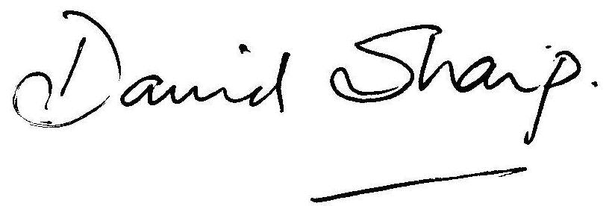

David Sharp, Clerk to the Parish Council

