Little Malvern & Welland Parish Council

NOTICE OF A PARISH COUNCIL MEETING TO BE HELD ON
MONDAY 17th FEBRUARY 2014 AT 7.30PM IN THE WELLAND PARISH HALL

Before the start of the meeting residents are invited to give their views and questions on issues on the agenda, or raise ISSUES FOR FUTURE CONSIDERATION.

AGENDA
1. APOLOGIES
To consider acceptance of apologies for absence from Councillors.

2. INTERESTS
i. Councillors Declarations of Disclosable Pecuniary Interests and Other Disclosable Interests regarding items on the agenda.
ii. Notification of changes to the register of interests.
iii. To consider written requests from councillors for the council to grant a dispensation for those with Disclosable Interests to take part in discussions or voting.
a. Cllr. Mary Pettit to take part in discussions in item 7i – planning application 13/01526/OUT
b. Cllr. Roger Cousins to take part in discussions in item 7i, ii and iii - planning applications 13/01526/OUT, 13/01388/FUL, 12/01087/OUT
c. Cllr. Andrea Calvesbert to take part in discussions in item 7iii – planning application 12/01087/OUT

- MINUTES
To consider for adoption the minutes of the last Parish Council meeting held on 20th January.

4. PROGRESS REPORTS AND OTHER MATTERS ARISING FROM THESE MINUTES

5. REPORTS BY DISTRICT AND COUNTY COUNCILLORS AND OTHER REPRESENTATIVES

6. COMMITTEE & WORKING PARTY REPORTS & RECOMMENDATIONS
  - Neighbourhood Planning Group:
  - Playing Fields:
a. To consider submitting an expression of interest for S106 funding to MHDC
b. To consider allowing advertising boards on Spitalfields
c. To consider grass cutting quotations

7. PLANNING
i To consider responses to the following and any late submitted applications:
Application No | From | Details
13/01526/OUT | Mr M Little  Land Adj. Old Post Office, Drake St | Outline application with all matters reserved for the erection of 30 dwellings (12 affordable)
14/00086/FUL | Mr John Drinkwater  Lombard Tree Farm | Proposed steel framed building to replace existing fodder store
14/00108/FUL | Mrs Catherina Rolinson  The Lovells, Garrett Bank | Change of use of existing ancillary accommodation and workshop for wine selling and holiday let from existing vineyard
ii. To consider making representation at Southern Area Development Control meeting regarding application 13/01388/FUL (Land at OS79514008 Marlbank).
iii. To consider whether to support an appeal by the Welland Residents Action Group against the recent ruling approving application 12/01087/OUT (Lawn Farm).
iv. Decisions notified.

8. HIGHWAYS & FOOTPATHS
Matters for report and consideration

9. CAR BOOT SALES
To consider applications for 2014

10. CORRESPONDENCE
See agenda notes.

11. FINANCE
To consider payment of invoices presented

12. ANY OTHER MATTERS FOR REPORT OR FOR FUTURE CONSIDERATION

13. DATE OF NEXT MEETING
Monday 17 March 2014
THE PUBLIC AND PRESS ARE INVITED TO ATTEND
11/02/14
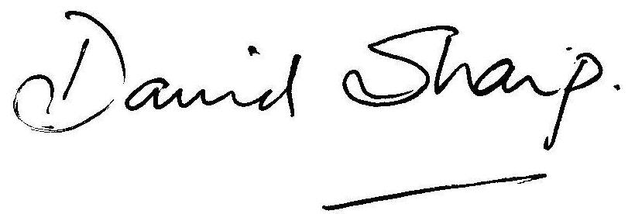
David Sharp, Clerk to the Parish Council

