KIDDERMINSTER FOREIGN PARISH COUNCIL
CHAIRMAN:
Councillor B. Phillips
Tel: 01299 861419
CLERK TO THE COUNCIL:
Mrs E. Whitehouse
Tel: 01299 861026

You are summoned to attend

A MEETING OF THE PARISH COUNCIL
to be held at

TRIMPLEY VILLAGE HALL
on
MONDAY 24th February 2014
at 7.45p.m.
(Please note date, venue and time of meeting)
Members of the public and
the press are welcome to attend.
The meeting will commence with a
PUBLIC LOCAL FORUM with planned attendance by West Mercia Constabulary officer
The Agenda for the Parish Council meeting is attached.

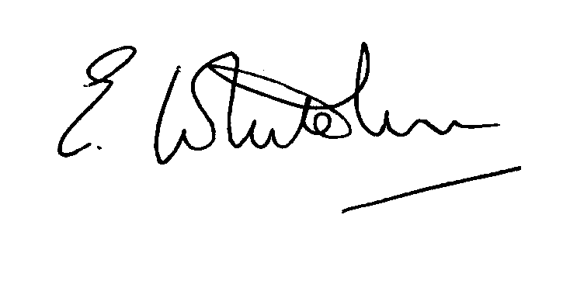

Dated: 14th February 2014 Clerk to the Council

e-mail: clerk.kiddfor.pc@googlemail.com

A G E N D A

(Note: The notation (I) indicates that the item is for information; (D) indicates that it requires a decision)

 | Police Report and Public Local Forum
 | Apologies for Absence and Approval of Reasons.
 | Declarations of Interest.
 | Approval of the Minutes of the Meeting of the Parish Council held 20th January 2014 |  | Enclosure 1
 | Planning and Development Control.
 | a. | Applications received up to date of meeting - inc:  14/0051 - Single and two storey rear extensions and front bay window extension at 26, LOW HABBERLEY, KIDDERMINSTER, DY115RA  14/0065 - Creation of 1 Unit holiday let accommodation with access, parking and associated works at ROCK HOUSE, LOW HABBERLEY, KIDDERMINSTER, DY115RQ | (D)  (D)
 | b. | Compliance Issues  Update. | (I)
 | Progress Reports / Matters Arising – inc. Highway matters  Flooding issues at Low Habberley – report on current situation – including funding and works scheduling  Footpath flooding – Trimpley Green – report on current situation  Grit Bin – Northwood Lane  Drain at Lightmarsh |  | (I & D)
 | Severn Trent Matters, including:-  Road closure  Fencing at Reservoir – Lock on gate. |  | (I)  (I)
 | Newsletter – Suggestion for items. Photos to be taken. |  | (I)
9. | Lengthsman  Tabling of any invoice for work undertaken.  Balance of funding |  | (D)
10. | Financial Reports and Payment of Accounts.
 | a) | Payments  Invoice tabled by the Lengthsman  Travel costs for Sir Thos. White Trust representative attending meeting  PAYE re Clerk | (D)  (D)
11. | Worcestershire CALC Reports and Notices |  | (I)
12. | County and District Council Matters and Other Correspondence.  - Parish Games Quiz night – any interested parties? |  | (D)
13. | Any report from the County or District Councillor representatives not already tabled
14. | Road Accident Record
15. | Other matters which the Chairman, after consulting members, feels to be of an urgent nature
16. | Next Meeting: confirmation : Monday 17th March at 7.45p.m.  at Trimpley Village Hall |  | .

