Little Malvern & Welland Parish Council

NOTICE OF A PARISH COUNCIL MEETING TO BE HELD ON
MONDAY 17th MARCH 2014 AT 7.30PM IN THE WELLAND PARISH HALL

Before the start of the meeting residents are invited to give their views and questions on issues on the agenda, or raise ISSUES FOR FUTURE CONSIDERATION.

AGENDA
1. APOLOGIES
To consider acceptance of apologies for absence from Councillors.

2. INTERESTS
i. Councillors Declarations of Disclosable Pecuniary Interests and Other Disclosable Interests regarding items on the agenda.
ii. Notification of changes to the register of interests.
iii. To consider written requests from councillors for the council to grant a dispensation for those with Disclosable Interests to take part in discussions or voting.

- MINUTES
To consider for adoption the minutes of the last Parish Council meeting held on 17th February.

4. PROGRESS REPORTS AND OTHER MATTERS ARISING FROM THESE MINUTES

5. REPORTS BY DISTRICT AND COUNTY COUNCILLORS AND OTHER REPRESENTATIVES

6. COMMITTEE & WORKING PARTY REPORTS & RECOMMENDATIONS
  - Neighbourhood Planning Group:
  - Playing Fields:
a) To consider items to be included in the expression of interest submission for S106 funding to MHDC.
b) To consider how to organise car boot sale public parking.

7. PLANNING
i To consider responses to the following and any late submitted applications:
Application No | From | Details
14/00257/HOU | Mr Richard Cope  Vicarage Cottage, Marlbank | Replace existing first floor side elevation window with larger window. (Retrospective)
13/01188/HOU | Mr Robert Hayter  2 Marlbank Road | Single storey porch to front elevation.
  - To consider making representation at Southern Area Development Management meeting regarding applications13/01388/FUL (Land at OS79514008 Marlbank) and 13/01526/OUT (Land Adj. Old Post Office, Drake St) if appropriate.
iii. Decisions notified.

8. HIGHWAYS & FOOTPATHS
Matters for report and consideration

9. CORRESPONDENCE
See agenda notes.

10. FINANCE
i. To consider payment of invoices presented
ii. To consider making a donation to aid the running of Upton-upon-Severn library.

11. ANY OTHER MATTERS FOR REPORT OR FOR FUTURE CONSIDERATION

12. DATE OF NEXT MEETING

THE PUBLIC AND PRESS ARE INVITED TO ATTEND
11/03/14
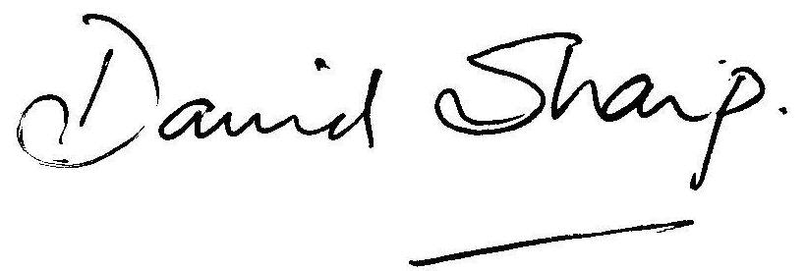
David Sharp, Clerk to the Parish Council

