KIDDERMINSTER FOREIGN PARISH COUNCIL
CHAIRMAN:
Councillor Mrs C Gammond
Tel: 01299 402929
CLERK TO THE COUNCIL:
Mrs E. Whitehouse
Tel: 01299 861026

You are summoned to attend

A MEETING OF THE PARISH COUNCIL
to be held at

TRIMPLEY VILLAGE HALL
on
MONDAY 18th August 2014
at 7.45p.m.
(Please note date, venue and time of meeting)
Members of the public and
the press are welcome to attend.
The meeting will commence with a
PUBLIC LOCAL FORUM with planned attendance by West Mercia Constabulary officer
The Agenda for the Parish Council meeting is attached.

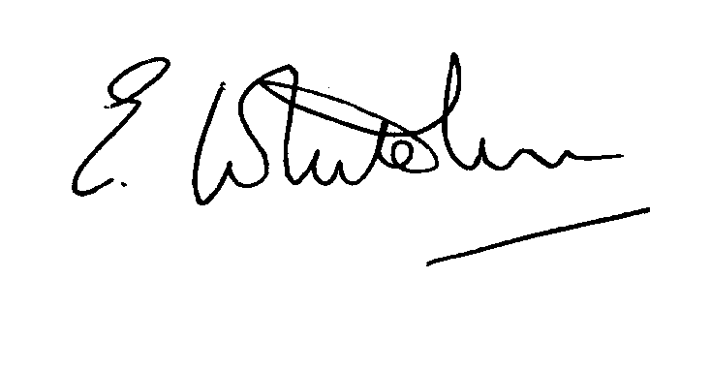

Dated: 11th August 2014 Clerk to the Council

e-mail: clerk.kiddfor.pc@googlemail.com

A G E N D A

(Note: The notation (I) indicates that the item is for information; (D) indicates that it requires a decision)
 | Police Report and Public Local Forum
 | Apologies for Absence and Approval of Reasons.
 | Declarations of Interest.
 | Approval of the Minutes of the Meeting of the Parish Assembly and the Parish Council held 21st July 2014 |  | Enclosure 1
 | Planning and Development Control.
 | a.  b. | Update on previous applications considered  New applications received, up to the date of the meeting – inc:  14/0445 – Alterations to raise height of existing grain storage unit at Holbeache House Farm, Trimpley  14/0462 – Relocation of gas tank from rear to front, and replacement shed at Joydean, Hill Farm, Northwood Lane, | (I)  (D)  (D)
 | c. | Compliance Issues  Update. | (I)
 | Progress Reports / Matters Arising – inc. Highway matters  a) Flooding – Near Mount Pool  b) Flooding – Low Habberley  c) Bulb Planting  d) Marsh – weed clearance  e) Roadside Hedges – cutting  f) Road surfaces – Valley Close and Upper Birch Lane  g) Hollies Lane  h) Noticeboards  i) VA Sign battery |  | (I & D)
7. | Lengthsman  Tabling of any invoice for work undertaken. |  | (D)
8. | Financial Reports and Payment of Accounts.
 | a) | Payments  Any invoice tabled by the Lengthsman  PAYE re Clerk  External Audit fee (if received)  Possible invoice for bulbs for planting near to village signs | (D)
 | b) | External Audit report from Grant Thornton | (I)
9. | Worcestershire CALC Reports and Notices  Funding issues for Worcs. CALC |  | (I)
10. | County and District Council Matters and Other Correspondence. |  | (D)
11. | Any report from the County or District Councillor representatives not already tabled
12. | Road Accident Record
13. | Other matters which the Chairman, after consulting members, feels to be of an urgent nature
14. | Next Meeting: confirmation : 15th September 2014 – at 7.45p.m. |  | (D)

