KIDDERMINSTER FOREIGN PARISH COUNCIL
CHAIRMAN:
Councillor C. Gammond
Tel: 01299 402929
CLERK TO THE COUNCIL:
Mrs E. Whitehouse
Tel: 01299 861026

You are summoned to attend the

ANNUAL PARISH MEETING
to be held at

TRIMPLEY VILLAGE HALL
on
MONDAY 21st July 2014
at 7.15p.m.
(Please note date, venue and time of meeting)
SPEAKER : Stephen Ashton
Senior Project Manager to talk about
Broadband Speed
Members of the public and
the press are welcome and encouraged to attend.
West Mercia Constabulary are also invited to attend.
This to be followed immediately by
Parish Council meeting
Agenda for both meetings overleaf

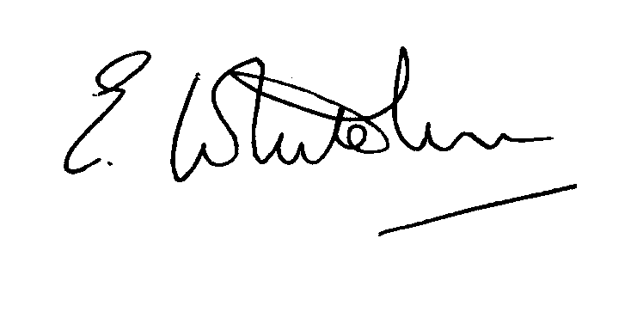

Dated: 12th July 2014 Clerk to the Council

e-mail: clerk.kiddfor.pc@googlemail.com

AGENDA
for the Annual Parish Meeting – 21st July 2014 – commencing at 7.15p.m.
(Note: The notation (I) indicates that the item is for information; (D) indicates that it requires a decision)

1. | Welcome by Parish Council Chairman to all present, including any apologies
2. | Information from Stephen Ashton, Senior Project Manager, who will talk to the meeting about Broadband speeds in the area. |  | (I)
3. | Any matters the attending public wish to raise with the Parish Council |  | (D)
4. | Possible Police Report – see* below. |  | (I)
This to be followed immediately by a meeting of the Parish Council
AGENDA
1. | Apologies for Absence and Approval of Reasons.
2. | *Police Report, if not previously given in Annual Parish Meeting
3. | Declarations of Interest.
4. | Approval of the Minutes of the Meeting(s) held on 16th June 2014 |  | Enc.
5. | Planning and Development Control.
 | a. | Applications previously considered  To receive updated information on progress | (I)
 | b. | Applications received up to date of meeting inc:  14/0318 Proposed inglenook fireplace and chimney at THE BANNERINGS, TRIMPLEY, BEWDLEY, DY121PW.  14/0337 Change of use of toilets to 2 No. holiday lets at CHARLESWOOD CARAVAN SITE, NORTHWOOD LANE, BEWDLEY, DY121AP. | (D)
 | c. | Compliance Issues | (I)
6. | Progress Reports.
 | a. | Highway Matters, to inc: | (I)
 |  | Flooding near to Mount Pool  Flood alleviation Works at Fountain, Low Habberley  + other highway matters including those raised in minutes of last meeting | (I & D)
 | b. | Marsh – weed eradication – work party | (D)
 | c. | Newsletter - distribution
7. | Lengthsman – inc. tabling of any invoice received  Also, a) matters itemised in last month’s minutes for attention  b) Hollies Lane – wash-out and debris traps |  | (D)
8. | Financial Reports and Payment of Accounts
 | a. | Accounts for Payment  Any invoice tabled from lengthsman  PAYE for Clerk  Chairman’s allowance  Clerk’s Expenses including Ink cartridge and Daffodil Bulbs | (D)
9. | Worcestershire CALC Reports and Notices (if any)  a) Funding of Worcs. CALC – request for support  b) Excessive speeds of vehicles using country roads – request from CALC meeting asking parishes to contact the police and highways to express our concerns on this matter. |  | (D)  (D)
10. | County and District Council Matters and other Correspondence  a. News Releases - Sounds for the Summer, Senior residents Showcase of Services |  | (I)
 | b. | Any report from the County or District Councillor representatives not already tabled
11. | Road Accident Record
12. | Other matters which the Chairman, after consulting members, feels to be of an urgent nature.  (NOTE: Any items requiring a decision that do not appear on the agenda must either be dealt with by means of delegated powers or be deferred for consideration at the next meeting).
13. | Next Meeting: confirmation of date : Monday 18th August 2014 at 7.45p.m. |  | .(I)

