KIDDERMINSTER FOREIGN PARISH COUNCIL
CHAIRMAN:
Councillor Mrs C Gammond
Tel: 01299 402929
CLERK TO THE COUNCIL:
Mrs E. Whitehouse
Tel: 01299 861026

You are summoned to attend

A MEETING OF THE PARISH COUNCIL
to be held at

TRIMPLEY VILLAGE HALL
on
MONDAY 20th October 2014
at 7.45p.m.
(Please note date, venue and time of meeting)
Members of the public and
the press are welcome to attend.
The meeting will commence with a
PUBLIC LOCAL FORUM with planned attendance by West Mercia Constabulary officer
The Agenda for the Parish Council meeting is attached.

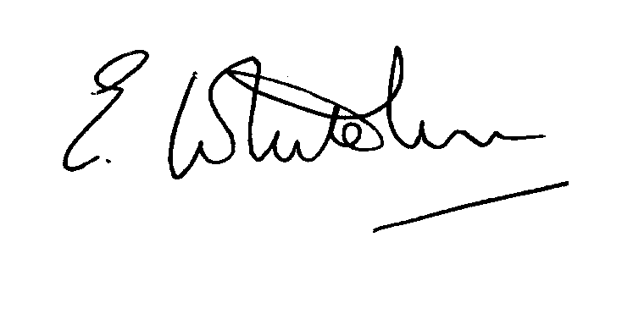

Dated: 12th October 2014 Clerk to the Council

e-mail: clerk.kiddfor.pc@googlemail.com

A G E N D A

(Note: The notation (I) indicates that the item is for information; (D) indicates that it requires a decision)
 | Police Report and Public Local Forum  If available – report and possible u-tube film of Country Crimefighter Awards |  | (I)
 | Talk by Tree Warden – re Ash Dieback |  | (I)
 | Apologies for Absence and Approval of Reasons.
Declarations of Interest
- Register of interests: Councillors are reminded of the need to update their register of interests
- To declare any Disclosable Pecuniary Interest in items on the agenda and their nature
- To declare any Other Disclosable Interests in items on the agenda and their nature
Councillors who have declared a Disclosable Pecuniary Interest or any Other Disclosable Interest must leave the room for the relevant items.
Failure to register or declare a Disclosable Pecuniary Interest may result in the commission of a criminal offence.
 | Approval of the Minutes of the Meeting of the Parish Council held 15th September 2014 |  | Enclosure 1
 | District Councillors’ reports ) to include updates on Wyre Forest  matters |  | (I)
 | County Councillors’ reports ) to include updates on highway matters |  | (I)
 | Planning and Development Control.
 | a.  b. | Update on previous applications considered  New applications received, up to the date of the meeting – inc: | (I)  (D)
 | c. | Compliance Issues  Update. | (I)
9. | Newsletter – Distribution |  | (D)
10. | Progress Reports / Matters Arising – inc. Highway matters  a) Flooding alleviation highway works  b) Bulb Planting  c) Marsh Weed eradication  d) Hedge and tree cutting  e) Noticeboards  f) Mary Moors Layby and flytipping  g) Grit bins – survey by Councillors re replenishment ready for winter. |  | (I & D)
11. | Lengthsman  Tabling of any invoice for work undertaken.  Lengthsman’s Resignation and Procedure for Appointment of New Contractor |  | (D)  (D)
12. | Financial Reports and Payment of Accounts.
 | a) | Payments  Any invoice tabled by the Lengthsman  PAYE re Clerk  Consideration of payment of invoice to District Council re uncontested election  Invoice for bulbs for planting near to village signs  Digger hire re silt trap – Mount Pool  Invoice for research – Forces War records | (D)
13. | Worcestershire CALC Reports and Notices |  | (I)
14. | County and District Council and Other Correspondence. |  | (D)
15. | Road Accident Record
16. | Other matters which the Chairman, after consulting members, feels to be of an urgent nature
17. | Next Meeting: confirmation : 17th November 2014 – at 7.45p.m. |  | (D)

