BROOME PARISH COUNCIL

Clerk to the Council: – Mr Marcus J. Hart
Apartment 2, Woodhamcote Manor, DY11 5XZ
01562 851769
marcushart78@yahoo.co.uk

Chairman – Cllr. Don Billington

To the members of Broome Parish Council:-

You are duly summoned to attend the next Meeting of Broome Parish Council on Wednesday 2nd December, 2015 at 7:30pm at Broome Village
Hall

AGENDA

- Apologies

- Declarations of Interest and Dispensations

- Public Question time (The meeting is adjourned for any member of the public to give their views on any agenda item or to raise issues for future consideration at the discretion of the Chairman)

- Minutes of the Previous Meeting

- Police Report

- District Councillor’s Report

- County Councillor’s Report

- Matters Arising

- Community Speed Watch/Speeding in Broome Lane Update

- Lengths man’s Update

- Councillors Complaints

- Planning Report

- Financial Report

- Clerk’s Payroll and Pension Arrangements

- Meetings Attended

- Footpaths Officer Report

- Correspondence

- Councillor’s Reports

- Emergency Plan

- Parish Localism Fund

- Litter Picking Contract

- Date of Next Meetings – 3rd February, 4th May, 7th September and 7th December
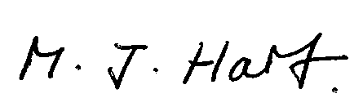
Marcus J. Hart
Clerk to Broome Parish Council

