KIDDERMINSTER FOREIGN PARISH COUNCIL
CHAIRMAN:
Councillor Mrs C Gammond
Tel: 01299 402929
CLERK TO THE COUNCIL:
Mrs E. Whitehouse
Tel: 01299 861026

You are summoned to attend the

ANNUAL PARISH MEETING
to be held at

TRIMPLEY VILLAGE HALL
on
MONDAY 20th APRIL 2015
at 7.45p.m.
(Please note date, venue and time of meeting)
Members of the public and
the press are welcome to attend.
The meeting will commence with a
PUBLIC LOCAL FORUM with planned attendance by West Mercia Constabulary officer
This to be followed immediately by
Parish Council meeting
Agenda for both meetings overleaf
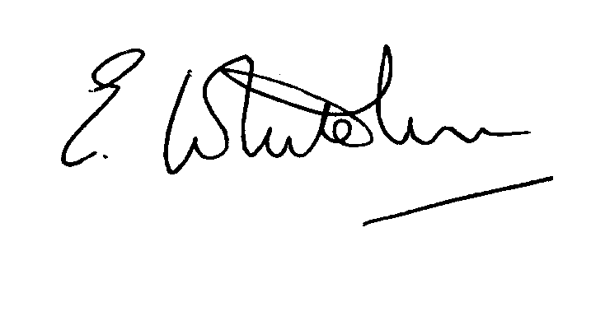

Dated: 10th April 2015 Clerk to the Council

e-mail: clerk.kiddfor.pc@googlemail.com

AGENDA
for the Annual Parish Meeting – 20th April – commencing at 7.45p.m.
(Note: The notation (I) indicates that the item is for information; (D) indicates that it requires a decision)

1. | Welcome by Parish Council Chairman to all present, including any apologies
2. | Any matters the attending public wish to raise with the Parish Council | (D)
3. | Police Report | (I)
4. | Presentation of Charity Accounts | (I)
AGENDA
for the Parish Council Meeting
(Note: The notation (I) indicates that the item is for information; (D) indicates that it requires a decision)
 | Apologies for Absence and Approval of Reasons.
Declarations of Interest
- Register of interests: Councillors are reminded of the need to update their register of interests
- To declare any Disclosable Pecuniary Interest in items on the agenda and their nature
- To declare any Other Disclosable Interests in items on the agenda and their nature
Councillors who have declared a Disclosable Pecuniary Interest or any Other Disclosable Interest must leave the room for the relevant items.
Failure to register or declare a Disclosable Pecuniary Interest may result in the commission of a criminal offence.
 | Approval of the Minutes of the Meeting of the Parish Council held 16th March 2015 |  | Enclosure 1
 | District Councillors’ reports ) to include updates on Wyre Forest  matters |  | (I)
 | County Councillor’s reports ) to include updates on highway matters |  | (I)
 | Planning and Development Control.
 | a.  b. | Update on previous applications considered  New applications received up to date of meeting– inc:  15/0179 - Removal of single storey extensions and construction of new single storey and two storey extensions at LITTLE GAINS, TRIMPLEY LANE, SHATTERFORD, BEWDLEY, DY121RD. | (I)  (D)
 | c. | Compliance Issues  Update. | (I)
8. | Progress Reports / Matters Arising |  | (I & D)
9. | Newsletter – distribution |  | (I)
10. | Lengthsman  Tabling of any invoice for work undertaken. |  | (D)
11. | Financial Reports and Payment of Accounts.
 | a) | Payments  Any invoice tabled by the Lengthsman  CALC Subscription  Trimpley Village Hall – Room Rental Fee  Holy Trinity Church, Trimpley – Churchyard Grant  Insurance premium  Misco Invoice for new computer  Clerk’s PAYE | (D)
 | b) | Approval of Accounts for 2014-15 | Enc. 2 (D)
 | c) | Bank Mandate requirements | (D)
12. | Worcestershire CALC Reports and Notices |  | (I)
13. | County and District Council and Other Correspondence. |  | (D)
14. | Road Accident Record
15. | Other matters which the Chairman, after consulting members, feels to be of an urgent nature
16. | Next Meeting: confirmation : 18th May 2015 – at 7.45p.m – being also the Annual Meeting of the Parish Council |  | (D)

