Parish Council of Alfrick and Lulsley Annual Meeting of the Parish Council

Tuesday 19th May 2009, at 7.30pm in the Village Hall, Alfrick.

Public Question Time. Members of the public may wish to raise matters of concern prior to the formal meeting.

Agenda - The meeting is opened by the existing chairman Cllr Mrs C Williams.

- To accept nominations and appoint a Chairman
- To accept nominations and appoint a Vice-Chairman
- Members' Apologies for Absence
- Members' Declarations of Interest
- Appoint councillors to committees etc; -
- Informal Housing Group and confirm terms of reference. ( 2008-9; Cllrs R Jackson, convenor, B Fishwick, P Brown, P Tebbit)
- Sphere Bus Committee. ( 2008-9; Cllrs Mrs C Williams,)
- Designate consultees on Planning Matters (2008-9; Alfrick, Cllrs B Fishwick, R Jackson; Alfrick Pound and Old Storridge, Cllr Mrs S Tolley, G Lowe; Lulsley, Cllrs Mrs C Williams, P Brown.)
- Appoint representatives to external organisations;
- Village Hall Committee; (2008-9; Cllr B Fishwick)
- 2 representatives to WCALC Area Meeting. ( 2008-9; Cllrs Mrs S Tolley, P Tebbit)
- Alfrick Charities Trustees; (2008-9; G M Brewin , P Brown, P Gilbert, L Higginson.)
- Allocation of Parish Plan Portfolios - if required.
- Confirm the minutes of the monthly meeting held 21/4/2009 and the Risk Assessment circulated in advance.
- Financial Matters
- Confirm Clerk's salary and hours of work for 2008-9 (NALC - SCP26 - £11.435/hr, 304hrs/yr)
- Confirm payment, Council Insurance Premium; quotations received -
Allianz- £645.21, Came & Co (Norwich Union) £510.37
- Confirm Payment, WCALC, - Membership Subscription, £245.31+vat - £277.57

- Planning Matters; Consider a response to;
09/00590/FUL - Remove masonry from disused railway bridge - Lulsley
- Correspondence & Publications Received Circulated in advance.
- Items for the next meeting
- Confirm the date of the next meeting – 16th June 2009 at 7.30pm, Alfrick Village Hall.
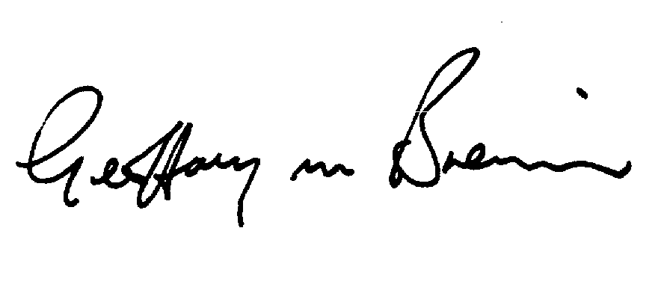G M Brewin, Clerk to the Council 11/05/2009

