KIDDERMINSTER FOREIGN PARISH COUNCIL
CHAIRMAN:
Councillor Mr. C. Grainger
Tel: 01299 403231
CLERK TO THE COUNCIL:
Mrs E. Whitehouse
Tel: 01299 861026

You are summoned to attend

A MEETING OF THE PARISH COUNCIL
to be held at

TRIMPLEY VILLAGE HALL
on
MONDAY 20th JULY 2015
at 7.45p.m.
(Please note date, venue and time of meeting)
Members of the public and
the press are welcome to attend.
The meeting will commence with a
PUBLIC LOCAL FORUM with planned attendance by West Mercia Constabulary officer
The Agenda for the Parish Council meeting is attached.

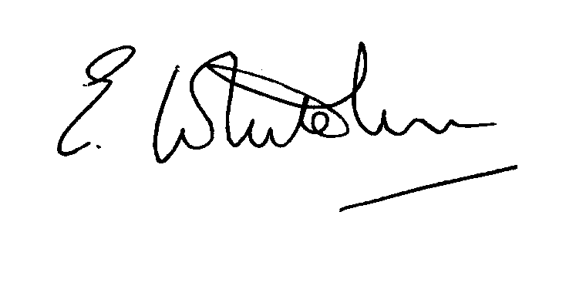

Dated: 11th July 2015 Clerk to the Council

e-mail: clerk.kiddfor.pc@googlemail.com

A G E N D A

(Note: The notation (I) indicates that the item is for information; (D) indicates that it requires a decision)
 | Police Report and Public Local Forum |  | (I)
 | Apologies for Absence and Approval of Reasons.
Declarations of Interest
- Register of interests: Councillors are reminded of the need to update their register of interests
- To declare any Disclosable Pecuniary Interest in items on the agenda and their nature
- To declare any Other Disclosable Interests in items on the agenda and their nature
Councillors who have declared a Disclosable Pecuniary Interest or any Other Disclosable Interest must leave the room for the relevant items.
Failure to register or declare a Disclosable Pecuniary Interest may result in the commission of a criminal offence.
 | Approval of the Minutes of the Annual Meeting of the Parish Council held 15th June 2015 |  | Enclosure 1
 | District Councillors’ reports ) to include updates on Wyre Forest  matters |  | (I)
 | County Councillors’ reports ) to include updates on highway matters |  | (I)
 | Planning and Development Control.
 | a.  b. | Update on previous applications considered  New applications received – to consider any applications received up to date of meeting. None as at date of agenda | (I)  (D)
 | c. | Compliance Issues / Appeals  To note a new appeal on Refusal of application 15/0113 – Crundalls Cottage. Representations to be made by 11th August for the appeal to be decided on the basis of written statements.  Update. | (I & D)
8. | Progress Reports / Matters Arising – inc. other any other items from the minutes, and further Highway matters |  | (I & D)
9. | Lengthsman  Tabling of any invoice for work undertaken. |  | (D)
10. | Financial Reports and Payment of Accounts.
 | a) | Payments  Any invoice tabled by the Lengthsman  PAYE re Clerk  Invoice for “no parking” signs | (D)
11. | Worcestershire CALC Reports and Notices |  | (I)
12. | County and District Council and Other Correspondence. |  | (D)
13. | Road Accident Record
14. | Other matters which the Chairman, after consulting members, feels to be of an urgent nature
15. | Next Meeting: confirmation : 17th August 2015 – at 7.45p.m |  | (D)

