BROOME PARISH COUNCIL

Clerk to the Council: – Mr Marcus J. Hart
Apartment 2, Woodhamcote Manor, DY11 5XZ
01562 851769
marcushart78@yahoo.co.uk

Chairman – Cllr. Don Billington

To the members of Broome Parish Council:-

You are duly summoned to attend the next Meeting of Broome Parish Council on Wednesday 2nd September, 2015 at 7:30pm at Broome Village
Hall

AGENDA

- Apologies

- Declarations of Interest and Dispensations

- Public Question time (The meeting is adjourned for any member of the public to give their views on any agenda item or to raise issues for future consideration at the discretion of the Chairman)

- Parish Council Vacancy To co-opt to fill the vacancies of the position of parish councillors.

- Minutes of the Previous Meeting

- Police Report

- District Councillor’s Report

- County Councillor’s Report

- Matters Arising

- Community Speed Watch/Speeding in Broome Lane Update

- Lengths man’s Update

- Councillors Complaints

- Planning Report

- Financial Report

- Clerk’s Payroll and Pension Arrangements

- Meetings Attended

- Footpaths Officer Report

- Correspondence

- Councillor’s Reports

- Broome Village Hall

- Emergency Plan

- Date of Next Meetings – 2nd December, 2015 at 7:30pm
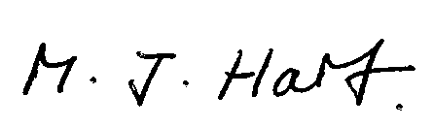
Marcus J. Hart
Clerk to Broome Parish Council

