RUSHOCK PARISH COUNCIL
Clerk to the Council: – Mr Marcus J. Hart
Apartment 2, Woodhamcote Manor, DY11 5XZ
01562 851769
marcus.hart@wyreforestdc.gov.uk

Chairman – Cllr. Laurence McCurrich

To the members of Rushock Parish Council:-

You are duly summoned to attend the Meeting of Rushock Parish Council on Thursday, 3rd September, 2015 at Rushock Village
Hall

AGENDA

- Apologies. To receive apologies and approve reasons for absence.

- Declarations of Interest and Dispensations.

- Public Question time (The meeting is adjourned for any member of the public to give their views on any agenda item or to raise issues for future consideration at the discretion of the Chairman)

- Parish Council Vacancy. To co-opt to fill the vacancy of the position of parish councillor.

- Minutes of the Previous Meeting. Approval of the minutes of the meeting held on 28th May.

- Progress Reports. On matters not covered elsewhere on the agenda.

- County Councillors Report.

- District Councillors Report.

- Police Report.

- Planning.

- Highways. Report on lengthsman activity and meeting with WCC Highways.

- Footpaths. Parish Paths Partnership Scheme, progress Report (TG) and Ramblers Pathwatch (TG).

- Finance. To update the PC on the financial position and authorise any expenditure and cheques for signing and sale of old lap top.

- Clerk. To consider the payroll and pension arrangements of the clerk and the contract.

- CALC and Other Meetings.

- Minutes from Neighbouring Parish Councils.

- Emergency Plan.

- Correspondence.

- Agenda items for future meetings.

- To note the date of the next meeting(s). Thursday, 19th November.
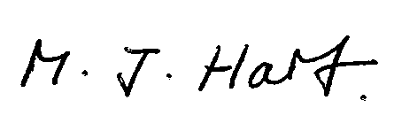
Marcus J. Hart
Clerk to Rushock Parish Council

