RUSHOCK PARISH COUNCIL
Clerk to the Council: – Mr Marcus J. Hart
Apartment 2, Woodhamcote Manor, DY11 5XZ
01562 851769
marcus.hart@wyreforestdc.gov.uk

Chairman – Cllr. Laurence McCurrich

To the members of Rushock Parish Council:-

You are duly summoned to attend the Meeting of Rushock Parish Council on Thursday 28th May, 2015 at the rise of the Annual Meeting at Rushock Village
Hall

AGENDA

- Apologies. To receive apologies and approve reasons for absence.

- Declarations of Interest and Dispensations.

- Public Question time (The meeting is adjourned for any member of the public to give their views on any agenda item or to raise issues for future consideration at the discretion of the Chairman)

- Minutes of the Previous Meeting. Approval of the minutes of the meeting held on 26th March.

- Progress Reports. On matters not covered elsewhere on the agenda.

- County Councillors Report.

- District Councillors Report.

- Police Report.

- Planning.

- Highways. Report on lengths man activity.

- Footpaths. Parish Paths Partnership Scheme. Progress Report (TG).

- Finance. To update the PC on the financial position and authorise any expenditure and cheques for signing.

- CALC and Other Meetings.

- Minutes from Neighbouring Parish Councils.

- Emergency Plan.

- Correspondence.

- Parish Council Vacancy.

- Agenda items for future meetings.

- To note the date of the next meeting(s). Thursday, 3rd September and Thursday, 19th November.

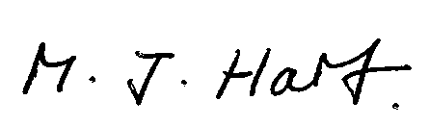
Marcus J. Hart
Clerk to Rushock Parish Council

