BROOME PARISH COUNCIL

Clerk to the Council: – Mr Marcus J. Hart
Apartment 2, Woodhamcote Manor, DY11 5XZ
01562 851769
marcushart78@yahoo.co.uk

Chairman – Cllr. Don Billington

To the members of Broome Parish Council:-

You are duly summoned to attend an Extraordinary meeting of Broome Parish Council on Wednesday 7th October, 2015 at 6:30pm at Broome Village
Hall

AGENDA

- Apologies

- Declarations of Interest and Dispensations

- Public Question time (The meeting is adjourned for any member of the public to give their views on any agenda item or to raise issues for future consideration at the discretion of the Chairman)

- Parish Council Vacancy To co-opt Michael Clarke and Warren Edwards to fill two of the vacancies of the position of parish councillors.

- Notes of the Previous Informal Meeting held on 2nd September and consideration of the proposals to be recommended.

- Date of Next Meeting – 2nd December, 2015 at 7:30pm

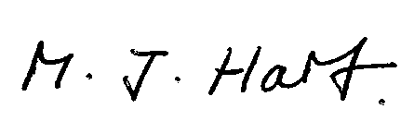
Marcus J. Hart
Clerk to Broome Parish Council

