Pebworth Parish Council
Extraordinary Meeting Agenda

To all Members of Pebworth Parish Council.
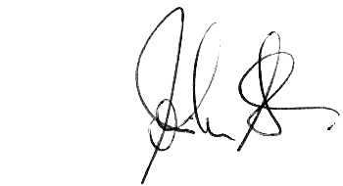
You are hereby summoned to an extraordinary meeting of the Parish Council to be held at the Village Hall on Monday 14th December starting at 7.00 pm for transacting the following business only.
John Stedman: Clerk to the Council 29 July 2026
Meeting Agenda
- Apologies: To receive apologies and agree the reason for absence:
- Declarations of Interests
  - Register of Interests: Councillors are reminded of the need to update their register of interests.
  - To declare any Disclosable Pecuniary Interests in items on the agenda and their nature.
  - To declare any Other Disclosable Interests in items on the agenda and their nature.
Councillors who have declared a Disclosable Pecuniary Interest, or Another Disclosable Interest which falls within the terms of paragraph 12(4) (b) of the code of conduct, must leave the room for the relevant items. Failure to register or declare a Disclosable Pecuniary Interest may result in the commission of a criminal offence.

- To receive a presentation from Craig McDonald of Rooftop Housing on the proposed development of land off Chapel Road Kirstie May-Jones of WDC will also be in attendance
- To consider any action or correspondence regarding the proposed Chapel Road development.
- To confirm meeting dates:
  - The next Ordinary Meeting of the Council is scheduled for Monday 4th January 7.00 pm
END

Following the formal Parish Council meeting members will informally consider the following matters: -

            - The council’s income and expenditure budgets and precept for 2016-17
A letter from WDC regarding the parish precept - circulated
            - The wording of the parish wide consultation letter regarding the proposed MUGA
Original draft letter circulated

