RUSHOCK PARISH COUNCIL
Clerk to the Council: – Mr Marcus J. Hart
Apartment 2, Woodhamcote Manor, DY11 5XZ
01562 851769
marcus.hart@wyreforestdc.gov.uk

Chairman – Cllr. Laurence McCurrich

To the members of Rushock Parish Council:-

You are duly summoned to attend the Annual Parish Meeting of Rushock Parish Council on Thursday 12th May, 2016 at 7:30pm at Rushock Village Hall

AGENDA

- Apologies. To receive apologies and approve reasons for absence.

- Declarations of Interest and Dispensations.

- Minutes of the Previous Meeting. Approval of the minutes of the meeting held on 28th May, 2015.

- Chairman’s Report. To receive the chairman’s report on the municipal year 2015-2016.

- Community Policing Report.

- Lengthsman Scheme.

- Resident’s Communications.

- Public Question time (The meeting is adjourned for any member of the public to give their views on any agenda item or to raise issues for future consideration at the discretion of the Chairman)

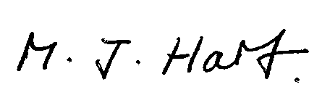
Marcus J. Hart
Clerk to Rushock Parish Council

