RUSHOCK PARISH COUNCIL
Clerk to the Council: – Mr Marcus J. Hart
Apartment 2, Woodhamcote Manor, DY11 5XZ
01562 851769
marcus.hart@wyreforestdc.gov.uk

Chairman – Cllr. Laurence McCurrich

To the members of Rushock Parish Council:-

You are duly summoned to attend the Annual Meeting of Rushock Parish Council on Thursday 12th May, 2016 at the rise of the Annual Parish Meeting at Rushock Village Hall

AGENDA

- Apologies.

- Declarations of Interest and Dispensations.

- Public Question time (The meeting is adjourned for any member of the public to give their views on any agenda item or to raise issues for future consideration at the discretion of the Chairman).

- Election of a Chairman.

- Election of a Vice Chairman.

- To note the Standing Orders.

- To note the Code of Conduct.

- To note the adopted Financial Regulations, Risk Assessment and Insurance Requirements.

- To nominate Councillors to Worcestershire CALC Area Meetings.

- Minutes of the Meeting. To approve the minutes of the meeting held on 28th May, 2015.

- Matters Arising.

- Adoption of the Accounts and Approval of Annual Return. To give delegated approval for completion of the accounts for the year 1st April 2015 – 31st March 2016 to the clerk and sign off to the chairman.)

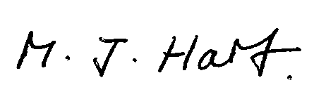
Marcus J. Hart
Clerk to Rushock Parish Council

