BROOME PARISH COUNCIL

Clerk to the Council: – Mr Marcus J. Hart
Apartment 2, Woodhamcote Manor, DY11 5XZ
01562 851769
marcushart78@yahoo.co.uk

Chairman – Cllr. Don Billington

To the members of Broome Parish Council:-

You are duly summoned to attend the next Meeting of Broome Parish Council on Wednesday 3rd February, 2016 at 7:30pm at Broome Village
Hall
AGENDA

- Apologies

- Declarations of Interest and Dispensations

- Public Question time (The meeting is adjourned for any member of the public to give their views on any agenda item or to raise issues for future consideration at the discretion of the Chairman)

- Minutes of the Previous Meeting

- Police Report

- District Councillor’s Report

- County Councillor’s Report

- Matters Arising

- Community Speed Watch/Speeding in Broome Lane Update

- Lengths man’s Update

- Councillors Complaints

- Planning Report (to consider the spreadsheet, note applications since the last meeting and appoint sub-committee)

- Financial Report (to include setting the 2016-2017 budget and precept, bank reconciliation and approve cheques for payment)

- Clerk’s Payroll and Pension Arrangements Update

- Meetings Attended

- Footpaths Officer Report

- Correspondence

- Councillor’s Reports

- Emergency Plan

- Parish Localism Fund (to note that the application has been successful and consider projects)

- Litter Picking Contract (to note that this has now been agreed and signed)

- Date of Next Meetings – 4th May, 2016 (Annual Parish Meeting and Annual Meeting), 7th September, 2016 and 7th December, 2016
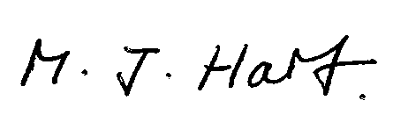
Marcus J. Hart
Clerk to Broome Parish Council

