BROOME PARISH COUNCIL

Clerk to the Council: – Mr Marcus J. Hart
Apartment 2, Woodhamcote Manor, DY11 5XZ
01562 851769
marcushart78@yahoo.co.uk

Chairman – Cllr. Don Billington

To the members of Broome Parish Council:-

You are duly summoned to attend the next Meeting of Broome Parish Council on Wednesday 7th December, 2016 at 7:30pm at Broome Village
Hall

AGENDA

- Apologies

- Declarations of Interest and Dispensations

- Public Question time (The meeting is adjourned for any member of the public to give their views on any agenda item or to raise issues for future consideration at the discretion of the Chairman)

- Minutes of the Previous Meeting (7th September, 2016)

- Parish Council Vacancy/Co-option

- Police Report

- District Councillor’s Report

- County Councillor’s Report

- Matters Arising

- Community Speed Watch/Speeding in Broome Lane Update

- Lengths man’s Update

- Councillors Complaints

- Planning Report (to consider the spreadsheet, note applications since the last meeting and appoint sub-committee)

- Financial Report (to include consideration of the financial spreadsheet, bank reconciliation and approve cheques for payment)

- Clerk’s Salary

- Meetings Attended

- Footpaths Officer Report

- CALC subscription

- BT Phone Box Consultation

- Correspondence

- Councillor’s Reports

- Emergency Plan

- Parish Localism Fund

- Date of Next Meetings

Wednesday, 1st February, 2017
Wednesday, 3rd May, 2017
Wednesday, 6th September, 2017
Wednesday, 6th December, 2017
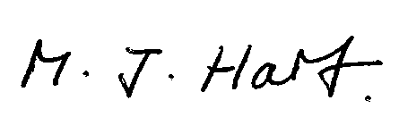
Marcus J. Hart
Clerk to Broome Parish Council

