RUSHOCK PARISH COUNCIL
Clerk to the Council: – Mr Marcus J. Hart
Apartment 2, Woodhamcote Manor, DY11 5XZ
01562 851769
marcus.hart@wyreforestdc.gov.uk

Chairman – Cllr. Terry Green

To the members of Rushock Parish Council:-

You are duly summoned to attend the Annual Meeting of Rushock Parish Council on Thursday 18th May, 2017 at the rise of the Annual Parish Meeting at Rushock Village Hall

AGENDA

- Election of a Chairman for 2017-2018.

- Election of a Vice-chairman for 2017-2018.

- Apologies.

- Declarations of Interest and Dispensations.

- Public Question time (The meeting is adjourned for any member of the public to give their views on any agenda item or to raise issues for future consideration at the discretion of the Chairman).

- To note the Standing Orders.

- To note the Code of Conduct.

- To note the adopted Financial Regulations, Risk Assessment and Insurance Requirements.

- To nominate Councillors to Worcestershire CALC Area Meetings.

- Minutes of the Meeting. To approve the minutes of the meeting held on 12th May, 2016.

- Matters Arising.

- Adoption of the Accounts and Approval of Annual Return. To approve the accounts for the year 1st April 2016 – 31st March 2017, firstly (a) the annual governance statement and secondly (b) the annual accounting statements).

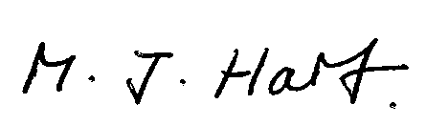
Marcus J. Hart
Clerk to Rushock Parish Council

