BROOME PARISH COUNCIL
Clerk to the Council: – Mr. Marcus J. Hart
Apartment 2, Woodhamcote Manor, DY11 5XZ
01562 851769
marcushart78@yahoo.co.uk

Chairman – Cllr. Don Billington

To the members of Broome Parish Council:-

You are duly summoned to attend a Meeting of Broome Parish Council on Wednesday 6th December, 2017 at 7:30pm at Broome Village Hall

AGENDA

- Apologies

- Declarations of Interest and Dispensations

- Public Question time (The meeting is adjourned for any member of the public to give their views on any agenda item or to raise issues for future consideration at the discretion of the Chairman)

- Minutes of the Previous Meeting

- Police Report

- District Councillor’s Report

- County Councillor’s Report

- Matters Arising

- Community Speed Watch/Speeding in Broome Lane Update

- Village Gateways

- Lengthsman’s Update

- Councillors Complaints

- Planning Report (to consider the spreadsheet and note any applications since the last meeting and appoint sub-committee)

- Clerk’s Salary

- Financial Report (to consider the spreadsheet and bank statements since the last meeting and to approve invoices for payment)

- Meetings Attended

- Footpaths Officer Report

- Correspondence

- Councillor’s Reports

- Emergency Plan

- Parish Localism Fund

- To agree the 2018 Meeting Dates (31st January, 2nd May (Annual Meeting and Annual Parish Meeting), 5th September and 5th December)

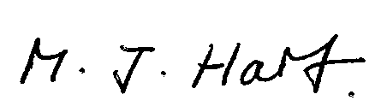
Marcus J. Hart
Clerk to Broome PC

