BROOME PARISH COUNCIL
Clerk to the Council: – Mr. Marcus J. Hart
Apartment 2, Woodhamcote Manor, DY11 5XZ
01562 851769
marcushart78@yahoo.co.uk

Chairman – Cllr. Nick Norton

To the members of Broome Parish Council:-

You are duly summoned to attend a Meeting of Broome Parish Council on Wednesday 30th January, 2019 at 7:30pm at Broome Village Hall

AGENDA

- Apologies

- Declarations of Interest and Dispensations

- Smartwater Presentation by Mr. Michael Simpson from West Mercia Police

- Public Question time (The meeting is adjourned for any member of the public to give their views on any agenda item or to raise issues for future consideration at the discretion of the Chairman)

- Minutes of the Previous Meeting

- Police Report

- District Councillor’s Report

- County Councillor’s Report

- Matters Arising

- Lengthsman’s Update

- Councillors Complaints

- Planning Report (to consider the spreadsheet and note any applications since the last meeting and appoint sub-committee)

- Financial Report (to consider the spreadsheet and bank statements since the last meeting and to approve invoices for payment and to set the budget and precept for 2019-2020)

- Meetings Attended

- Footpaths Officer Report

- Correspondence

- Councillor’s Reports

- Emergency Plan

- Parish Localism Fund

- To note the 2019 Meeting Dates (15th May (Annual Meeting and Annual Parish Meeting), 4th September and 4th December)

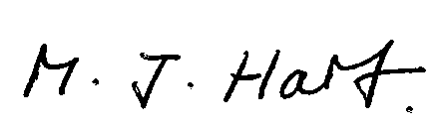
Marcus J. Hart
Clerk to Broome PC

