BROOME PARISH COUNCIL
Clerk to the Council: – Mr. Marcus J. Hart
Apartment 2, Woodhamcote Manor, DY11 5XZ
01562 851769
marcushart78@yahoo.co.uk

Chairman – Cllr. Nick Norton

To the members of Broome Parish Council:-

You are duly summoned to attend a Meeting of Broome Parish Council on Wednesday 4th December, 2019 at 7:30pm at Broome Village Hall

AGENDA

- Apologies

- Declarations of Interest and Dispensations

- Public Question time (The meeting is adjourned for up to 30 minutes for any member of the public resident in the Parish to give their views on any agenda item or to raise issues for future consideration at the discretion of the Chairman)

- Minutes of the Previous Meeting

- Police Report

- District Councillor’s Report

- County Councillor’s Report

- Matters Arising

- Lengthsman’s Update

- Litter Picking and Bin Emptying

- Councillors Complaints

- Planning Report (to consider the spreadsheet and note any applications since the last meeting and appoint sub-committee)

- Financial Report (to consider the spreadsheet and bank statements since the last meeting and to approve invoices for payment )

- Meetings Attended

- Footpaths Officer Report

- Correspondence

- Councillor’s Reports

- To Discuss the Smartwater rollout

- To Discuss the Parish Council Vacancy

- To Discuss Tree warden Vacancy

- Parish Localism Fund

- To note the 2019 and 2020 Meeting Dates (29th January, 29th April (Annual Meeting and Annual Parish Meeting), 2nd September and 2nd December)

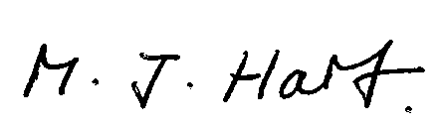
Marcus J. Hart
Clerk to Broome PC

